Amnesty International Salisbury Group

Minutes of the Monthly Meeting on Thursday 13th February 2020
7.30 pm 28 Attwood Road
1 | Chairman’s Welcome  Present: Andrew, Eddie, Ria, Fiona, Peter, Lesley  Apologies: Phil, Tony, Michael S, Michael P, Joanna | AH
2 | Minutes of previous Meeting – These were agreed | LC
3 | Treasurer’s Report - £1,660.47 (Bank)  £30.06 (Cash) | MP
4 | Campaign Reports  Death Penalty  Please see the Salisbury Group Website www.salisburyai.com for the full international update covering the USA, Pakistan, Saudi Arabia, Japan, Singapore and India.  International Update  - An email was received from Reprieve with the upsetting news that Kris Maharaj’s evidentiary hearing had again been delayed – and this time indefinitely. Supporters were asked to add their name to a Reprieve petition.  - In the US, an execution took place in the State of Texas and a prisoner on death row in Georgia was granted clemency. Bills to repeal the death penalty have been filed and/or are going through the legislature in Oklahoma, Colorado and Washington State.  - In Florida, the Supreme Court has overturned a landmark precedent, meaning that Judges will again be able to impose death sentences without the unanimous recommendation of the Jury.  - A report published by AI shows how the Saudi Arabian authorities are using a counter-terrorism Court – the Specialised Criminal Court – as a weapon to systematically silence peaceful opposition in the country. Vague charges are made, which often equate peaceful political activities with terrorism. Some of those involved have been given death sentences. (Click on the link for access to the full report – Muzzling Critical Voices: Politicised trials before Saudi Arabia’s Specialised Criminal Court.)  - The Lahore High Court overturned the death sentence imposed on the former President of Pakistan, Pervez Musharraf, declaring the legal process unconstitutional.  Urgent Actions:  - Nigeria – UA164/19 - Nigerian authorities have continued to detain human rights defenders Omoyele Sowore and Olawale Bakare at the Department of State Services in Abuja, and Agba Jalingo in Calabar prison, southern Nigeria, since their arrests in August. They are facing trumped-up charges of treason – for which the maximum penalty is death - because they demanded government accountability. They must be released immediately and unconditionally. (Circulated to the Group: 15.1.20)  - Bahrain – An email action was received from AIUK in respect of the two democracy activists – Hussain Ali Moosa and Mohamed Ramadhan – who are at risk of execution. (Circulated to the Group – 16.1.20.)  - South Sudan - An on-line action was received from the Amnesty Anti-Death Penalty Project on behalf of Magai Matiop Ngong, who was sentenced to death at 15, without being allowed access to a lawyer. He has spent two years on death row and is now l7. In 2018 he was finally given a lawyer, who has helped him to file an appeal. (Circulated to the Group 3.2.20.)  The Guardian featured an Amnesty advertisement on Saturday 8th February calling for texts on behalf of Magai to be sent to 70 505. (Circulated to the Group 9.2.20.)  An email request was received from Amnesty IAR on 12.2.20 asking for Magai’s case to be shared on Twitter and Facebook. Posted on 13.2.20.  - Iran – An email action was received from AIUK in respect of Houshmand Alipour, from Iran’s Kurdish minority, who is at risk of execution following an unfair trial’ and a ‘false conviction’ said to be obtained under torture. He had been found guilty of ‘armed rebellion against the state’ and ‘spreading propaganda against the system. (Circulated to the Group 6.2.20.)  - India – UA 05/20 – Four men are at immediate risk of execution following their conviction of gang-rape and murder. Amnesty recognises the shocking nature of this crime, and expresses the utmost sympathy for the family of the victim, but it does oppose the death penalty in all cases as the ultimate cruel, inhuman and degrading punishment. Supporters are asked to call on the Government to show mercy to the four men, but also to allocate adequate resources for the effective implementation of laws, improve conviction rates and ensure certainty of justice without recourse to the death penalty. (Circulated to the Group 9.2.20.)  Campaigning:  - A report for 2019 has been received from the Anti-Death Penalty Project. Follow the link for the full report which details:  - The Singapore postcard campaign  - The DP workshop at last year’s AIUK AGM  - Speaker events  - A demonstration at the Embassy against the use of the death penalty in the USA  - The monthly newsletter (?)  - The showing of the film ‘Guilty’ to mark the World Day Against the Death Penalty  - The expansion of the anti-death penalty network from 2,500 to over 5,000  The report recognises that the Project has not achieved everything it wished, but the hope is that this year’s programme will be more effective.  The Project is planning to focus throughout the year on the case of Magai Matiop Ngong (see Urgent Actions above), and will be asking for Groups’ involvement in raising the profile of his case and putting pressure on the Government of South Sudan to change his sentence.  - The Group is hoping to have a presence at the Studio Theatre, where they will be performing The Thrill of Love (the story of Ruth Ellis, the last woman to be hanged in the UK) on 23rd-28th March.  - It has been agreed that the film Just Mercy will be shown at The Arts Centre in partnership with the Salisbury Amnesty Group on Wednesday 4th November. The film is a legal drama based on the true story of a lawyer’s fight to save the life of a man on death row, and was released in the UK on 17th January. It stars include Jamie Foxx, Rafe Spall and Brie Larson. Follow the link for an article on the film by Ed Pilkington – New York – in The Guardian.)  North Korea  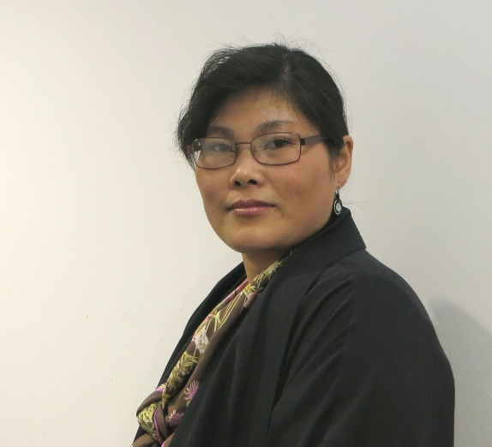  - As there is no AI Group in New Malden, it was agreed that FD would contact Jihyun Park (pictured: photo, Salisbury Amnesty) for advice regarding the donation the Group wish to make to the Korean Group.  - Kenny Latunde-Dada had forwarded a copy of a joint letter sent by a number of Human Rights bodies (ICNK), including Amnesty, to Prime Minister Abe, expressing concern about Japan’s decision to withdraw its support as sponsor on North Korean resolutions at the Human Rights Council.  - See later for information regarding Evensong at Salisbury Cathedral on 12th March.  - FD had been in contact with Kenny regarding the performances of the Korean play What Remains of Us at The Salberg on 14th-16th May. Jihyun plans to come to the performances on 15th and 16th, and Kenny hopes to do so. FD will liaise regarding accommodation. LC and PC will go to the performance on 14th. Others will be needed for 15th and 16th.  FD had contacted AI regarding a petition. This will focus on the Don’t Send Refugees back to North Korea and will be sent to the President of China, with copies to the Chinese and North Korean Embassies in London.  Refugees  - FD will attend the Climate Strike event in the Market Square on 14th February  - The planned Vigil remains on hold – a possibility for Refugee Week, which takes place from 15th – 21st June. Fiona will order ‘I Welcome Refugees’ cards.  - RW informed the Group that the Bohemian Football Club have put the Amnesty slogan ‘Refugees Welcome’ on their strip.  - EB suggested that the Group should send a donation of £100 to the Refugee Council. This was agreed. | LC  All  TM  FD  All  AH
5 | Social Media Report  Web and other media statistics, January 2020.  Web site  The figures are:  Views  All time: 15,007 so we have passed the 15,000 mark.  The new, combined statistic has appeared which seems to be a combination of Website followers and Facebook followers and says it is now 555. This is an increase of 1 from last month.  Top country views:  Continuing the trend of the UK being the highest with smaller numbers from the USA  Top posts:  - The piece on Sportswash  - ‘About us’ which is always encouraging.  Twitter  Impressions:  I am not able to explain this extremely high figure since no individual tweet is showing a number as high as this. However, Chemring may account for some of this.  The top tweet:  - Again the item on Sportswash  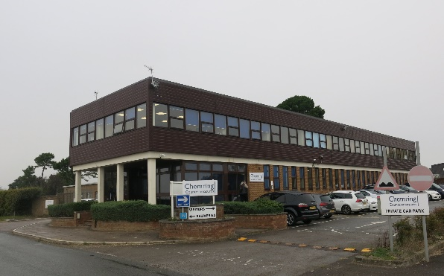  The tweet in September concerning Salisbury based Chemring and the supply by the firm of CS gas to HKPF has had a record number of impressions and now stands at 20,452 and significant increase of 7,845 on last month’s figure of 12,607.  Chemring factory at High Post –pic: Salisbury Amnesty  Facebook  Two interesting months and the platform is rapidly becoming our main means to promote the group and human rights. Again, the top post concerned the Sportswash piece in Saudi.  Top posts in January:  - Piece on increased use of cameras and facial recognition  - Happy New Year! piece  Tumbler  We have 9 followers and 18 following, no change.  YouTube & Flickr  No major changes to report.  Group  Web site: www.salisburyai.com Twitter: www.twitter.com/salisburyai  Facebook: www.facebook.com/salisburyai Tumblr: www.salisburyai.tumblr.com  Content always welcome! | PC
  July | Aug | Sept | Oct | Nov | Dec | Jan
  109 | 187 | 246 | 192 | 211 | 227 | 202
   | Dec | Jan
  UK | 153 | 129
  USA | 35 | 31
  India |  | 7
  July | Aug | Sept | Oct | Nov | Dec | Jan
  967 | 1142 | 11,6k | 2512 | 3208 | 2564 | 14k
  July | Aug | Sept | Oct | Nov | Dec | Jan
  295 | 853 | 2,094 | 874 | 786 | 399 | 226
6 | Monthly Action  - Groups/members and supporters are asked to write letters or seek further signatures for the Trip Adviser campaign, asking them to pull out of illegal Israeli settlements in Occupied Palestinian Territories.  - India: Free the Bhima Koregaon 9 (BK9) – An email action to the Indian High Commission calls for the immediate release of the nine activists imprisoned following false accusations by the Government.  - Follow the link for the new report ‘Without my Family’, produced by the Refugee Council and Save the Children, highlighting the impact of family separation on child refugees in the UK. The UK is one of the only countries in Europe to prevent child refugees from sponsoring their family members to join them.  - Groups are invited to nominate activists and human rights defenders for the Amnesty Brave Awards. They can be put forward on Facebook, Twitter and Email.  - Follow the link to watch the film made by Olivia Colman and Steve Ali, discussing which human rights they would miss the most. The film was made to highlight Amnesty’s work with refugees.  - Follow the link for information on this year’s Football Welcomes Weekend, which takes place on 18th-19th April. | All
7 | Evensong at Salisbury Cathedral  - AH confirmed this will take place at 5.30 pm at the Cathedral.  - Ben Rogers has confirmed his availability.  - The Cathedral will provide candles and drip shields.  - The poem ‘A Dream’ by Bandi (from the collection ‘The Red Years: Forbidden Poems Inside North Korea’ will be the Group reading – to be read by AH.  - The congregation will be invited to sign the petition calling on the President of China to release the Uyghur student, Yiliyasijiang Reheman. A copy will be sent to the Chinese Embassy in London | All  AH  FD
8 | Regional Conference  Groups and individual members have been invited to attend the International SW Conference in Exeter on Saturday 7th March from 10.00 to 16.00. It takes place at The Mint Methodist Church Centre, Fore Street, EX4 3AT.  FD, AH, PC and LC will be attending. Individuals will need to book their places. | All
9 | Market Stall  The date of 6th June is not available and the Group have been offered Tuesday 7th July or Saturday 11th July. It was agreed that Saturday 11th would be preferable.  Members and supporters are reminded to collect items for sale. | AH  All
10 | Citizenship Day  The date has been confirmed as Tuesday 30th June, and will involve the morning only.  A meeting will be arranged to check the format within the reduced time available. | AH  FD  RW
11 | The Southampton Group  The Group are holding an Exhibition from 17th to 29th February in Southampton Central Library. The Exhibition is of PEN portraits of imprisoned and ‘disappeared’ journalists in Eritrea. | FD
12 | Human Rights Act  It was agreed that changes in Government appointments, following the re-shuffle, give cause for concern. Geoffrey Cox is likely to be overseeing the review of the Human Rights Act, and Suella Braverman has been appointed Attorney General. Follow the links for postings on the Salisbury Amnesty Group website with further details. | All
13 | AOB  The Deputy Manager from Stratford Lodge has requested a talk by the Group for 10 young people. It was agreed that LC and RW would make contact with a view to responding to her request | FD  RW  LC
14 | Forthcoming Events  - Evensong – Salisbury Cathedral – 12th March  - The Thrill of Love - The Studio Theatre – 23rd-28th March  - Refugee Vigil – TBC  What Remains of Us’– The Salberg – 14th-16th May  - Citizenship Day – 30th June  - Market Stall – 11th July  - Amnesty film Just Mercy – Salisbury Arts Centre – 4th November. | All
Next Meeting: Thursday 12th March (TBC)
Time: following the Cathedral Service
Venue: The New Inn, New Street, Salisbury
A meal followed by the Group Meeting.

www.salisburyai.com www.twitter.com/salisburyai
Should you wish no longer to receive Minutes of meetings, or other communications from the Group, please let us know by emailing our Group Secretary at Donovan.fiona@gmail.com

