DEATH PENALTY REPORT: OCTOBER - NOVEMBER 2020
Date format: day/month/year

The death penalty is the ultimate cruel, inhuman and degrading punishment. Amnesty opposes the death penalty in all cases without exception - regardless of who is accused, the nature or circumstances of the crime, guilt or innocence or method of execution.

WORLD DAY AGAINST THE DEATH PENALTY – 10TH OCTOBER 2020

- Amnesty International held a live online discussion on the Death Penalty, at which the speakers were Kim Manning Cooper, Dr Bharat Malkani and Chiara Sangiorgio. Follow the link for a report on the event.

- Follow the link for the Joint Declaration made by the EU High Representative and Council of Europe Secretary General.

- Follow this link for the Statement issued by Amnesty International on WDADP expressing concern that, in the year since the African Court on Human and People’s Rights gave fresh impetus to the global campaign for the abolition of the death penalty by declaring the mandatory death penalty ‘unfair’ and a ‘failure in due process’, at least 4 countries – Botswana, Egypt, Somalia and South Sudan – have carried out executions.

- Kazakh Foreign Minister Mukhtar Tileuberdi addressed the World Day Conference attended by Heads of Foreign Ministries, representatives from the UN and from Human Rights Organisations, and spoke out against the death penalty (see below).

International Report (from 10.10.20 – 10.11.20)

- Kazakhstan – 10.10.20 – At the World Day Conference (see above) Mr Tileuberdi supported the aim of declaring Central Asia and Mongolia the first region in the world to be free of the death penalty. Participants at the meeting commended the decision of President Kassym-Jomart Tokayev to join the Second Protocol to the ICCPR. (Kazakhstan has maintained a moratorium on the death penalty since December 2003. (Source: The Astana Times.)

- Bangladesh –

  - 12.10.20 – Following protests in cities across the country at the Government’s failures to tackle the problems of sexual assault and rape, the death penalty has been introduced for those convicted of rape. Referring to footage of a gang rape on Facebook, Sultan Mohammed Zakaria, South Asia researcher at Amnesty, said ‘This truly disturbing footage demonstrates the shocking violence that Bangladeshi women are routinely being subjected to. In the vast majority of these cases, the justice system fails to hold the perpetrators responsible.’ Amnesty has pointed out that the issue is not the severity of the punishment but the failure of the courts to achieve convictions, and the fear of victims of coming forward. (Source: The Guardian.)

  - 13.10.20 – Human Rights Watch has spoken out against the introduction of the death penalty for rape, saying the Government should institute real reforms, provide services and remove barriers to justice. (Source: Human Rights Watch.)

  - 15.10.20 – Michelle Bachelet, the UN Commissioner for Human Rights, issued a statement calling for governments to step up actions against crimes of rape and other forms of sexual violence, but saying that capital punishment and torture were not the answer – ‘I share the outrage and stand in solidarity with the survivors, and with those demanding justice. But I am concerned that there are also calls – and in some places laws already being adopted – bringing in cruel and inhuman punishments and the death penalty for perpetrators’. Note: This statement was in reference to Bangladesh but included other countries such as Algeria, India, Morocco, Nigeria, Pakistan and Tunisia. (Source: UN News.)

  - 3.11.20 – The Bangladeshi Government announced the approval of the amendment to the Women and Children Repression Prevention Bill. Courts will, as a result, be able to impose the death penalty on those convicted of rape as an alternative to the previous maximum sentence of life imprisonment. (Source: The Organisation for World Peace.)

  - 8.11.20 – The Bill was introduced in Parliament and sent to the Standing Committee for further examination. Their report is requested within 7 days. (Source: Dhaka Tribune.)

- EU/Korea – 13.10.20 – The Ambassadors of the European Union and 27 Member States issued a joint statement calling for the full abolition of the death penalty in Korea. (Source: Korea Times.)

- United States

  - North Carolina – 14.10.20 – Follow the link for an excerpt from ‘Racist Roots: Origins of North Carolina’s Death Penalty’. This is a comprehensive project being carried out by the Center for Death Penalty Litigation, which includes more than 30 pieces chronicling the evolution of the death penalty over time, and connecting them to a broader historical framework. The excerpt focuses on Native Americans. (Source: The Progressive Pulse.)

  - US Federal Executions –

    - 17.10.20 - Lisa Montgomery, convicted of the killing of a woman and stealing her unborn baby, is scheduled to die by lethal injection in Terre Haute on 8th December. This would be the first federal execution for 67 years of a woman. Her lawyers argue that she has brain damage as the result of childhood beatings, and suffers from psychosis and other mental health conditions. (Source: The Guardian.)

    - 17.10.20 - William Barr, the Attorney General, has announced the decision to proceed with the execution of Brandon Bernard on 10th December. Mr Bernard was convicted of the murder of two Church Ministers. (Source: The Guardian.)

  - California –

    - 23.10.10 – Prosecutors have confirmed that they will seek the death penalty in the case of Scott Peterson at his re-sentencing. Mr Peterson, who was found guilty of killing his wife and unborn son, had had his death sentence overturned because of ‘problems with jury selection during his trial’. (Source: NBC News.)

    - 26.10 20 – Having already declared a moratorium on executions, Governor Newsom made an unprecedented Court filing asserting the State death penalty law was applied in a racist manner against African Americans. He argued that, before Imposing a death sentence, a jury should be required to find beyond reasonable doubt that it was the ‘proper punishment’ rather than life without parole. Governor Newson said also that jurors should be not be allowed to consider factors such as other violent acts committed by the defendant unless there was unanimous agreement that these had occurred. Such standards would make it more difficult for jurors to be persuaded by prosecutors to return a death sentence. (Source: San Francisco Chronicle.)

  - Florida – 30.10.20 – In a 5:1 ruling, the Florida Supreme Court scrapped a longstanding legal requirement to review death sentences to ensure they are not a ‘disproportionate’ punishment. Justice Jorge Laborga dissented, saying the majority were taking ‘the most consequential step yet in dismantling the reasonable safeguards contained within Florida’s death penalty jurisprudence’. This change had come into effect as the Supreme Court upheld the death sentence of Jonathan Huey Lawrence, whose attorneys had argued that his death sentence was disproportionate, at least in part because of his mental health issues. (Source: News4Jax.)

  - Tennessee – 7.11.20 – Governor Bill Lee has granted Pervis Pane a temporary reprieve due to the Covid-19 pandemic. Mr Pane was scheduled to be executed on 3rd December, and he has now been given a date of 9th April 2021. His attorney has said ‘This additional time will also allow us to investigate Mr Payne’s strong innocence claim, together with the Innocence Project.’ The reprieve would also enable legislation to be passed, allowing a defendant sentenced to death still to bring a petition under the claim of intellectual disability. (Source: The Commercial Appeal.)

- Saudi Arabia –

  - It was announced by Human Rights Watch that Saudi prosecutors are seeking the imposition of the death penalty for 8 Saudi men charged with protest-related crimes. HRW have said that ‘Some of the crimes listed (on the charge sheets) were allegedly committed while the men were between the ages of 14 and 17’, and these included one aged 9. All 8 have been in pre-trial detention for up to two years. Deputy Middle East Director of HRW, Michael Page, called for the country to ban the death penalty against alleged child offenders in all cases. (Source: Human Rights Watch.)

  - 22.10.20 – The Saudi Government has insisted that, following the Royal Decree, executions for crimes committed by minors have been abolished. They have said, ‘it has found no basis to substantiate HRW’s claim that Saudi prosecutors will seek the death sentence for juvenile offenders. HRW, however, says it has obtained and analysed the charge sheets that included the eight in 2019. (Source: WQOW TV News 18.)

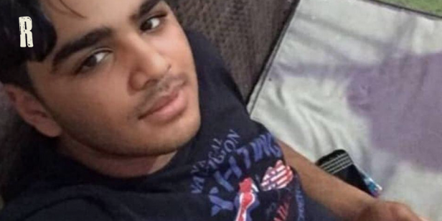
  - 30.10.20 – The Public Prosecutors moved ahead with their case against Mohammed al Faraj (pictured – photo: Reprieve), and did not withdraw their demand for a death sentence for his ‘crimes’ which include attending a family funeral at the age of 9. This calls into question the seriousness with which they are taking the Royal Decree to halt death sentences for children. Reprieve will continue to monitor the case, (Source: Reprieve.)

- Egypt – 22.10.20 – Egyptian authorities have carried out 49 executions in 10 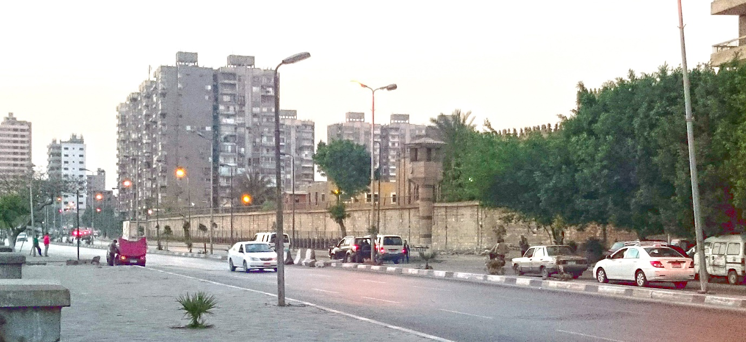days – 15 men convicted of alleged involvement in 3 cases of political violence, 2 women, and 32 men convicted in criminal cases - between 3rd and 13th October. Following charges of political violence, 13 of the men had been held in Scorpion Prison in Cairo (pictured – photo Wikipedia). Their executions followed a suspicious incident inside the prison’s death row, in which 4 prisoners who had killed 4 security personnel were killed by Interior Ministry Forces. The claim was made that the men were trying to escape. (Source: Human Rights Watch.)

- India –

  - 28.10.20 – A local court in Warangal imposed the death penalty on Sanjay Kumar Yadav, a migrant worker, who had been found guilty of the murder of nine people. (Source: The Indian Express.)

  - 2.11.20 – The Orissa High Court has reduced the death sentence imposed on Kalia Manna to life imprisonment. On 10th September Mr Manna had been convicted of the rape and murder of a child, but it was ruled at the Hearing that the crime of rape could not be proved, and he was acquitted of the charge. (Source: The New Indian Express.)

- Botswana – 30.10.20 – Deprose Muchena, AI’s Director has raised concerns about the ‘the alarming rise in executions under President Mokgweetsi Masisi Four people have been hanged in the course of his first year in office. (Source: Amnesty International.)

- United Arab Emirates – 4.11.20 – The Supreme Court ordered a fresh Hearing in the case of two men – one British and one Pakistani – who had been convicted of possessing and selling drugs and sentenced to death in 2019. The Legal Consultant acting for the Briton cited errors he claimed had been made in the arrest procedure, and the fact that the ‘verdict did not clarify whether the Panel of three Judges at the Court of First Instance was unanimous in their verdict.’ (Source: Khaleej Times.)

- Yemen – 6.11.20 – Human Rights Watch called on the Houthi authorities to quash the death sentences and unconditionally release the four journalists - Abdul Khaleq Amran, Akram Al-Walidi, Hareth Humaid and Tawfiq Al-Mansouri - who faced an unfair trial in 2015 following politically motivated charges of treason and spying for foreign states. They have had only irregular and restricted family visits, experienced lack of access to legal assistance and received inadequate medical care. (Source: Human Rights Watch.)

- Iran – 10.11.20 – Reza Tabrizi, a Paralympic World Champion, has been arrested and could face the death penalty following his questioning on Instagram of why gyms had been closed whereas religious shrines were remaining open in the Covid-19 Pandemic. (Source: The Telegraph.)

Urgent Actions

- Saudi Arabia –

  - A request was received from Reprieve in respect of Mohammed Essam al-Faraj, who was arrested at 15 and accused of ‘crimes’ including attending a family funeral. He has not been given access to a lawyer, and his ‘confession’ was obtained under torture. He is going to Court shortly, and there are fears that – despite the recent Royal Decree – the prosecution will ask for the death penalty. Follow the link above to sign the petition. (Circulated to the Group 13.10.20)

  - A further request was received from Reprieve, asking for Mohammed’s case to be shared on social media platforms. (posted on Facebook and Twitter 26.10.20.)

- Nigeria – UA 137/20 – As noted in last month’s report, Yahaya Sharif-Aminu , a 22-year-old singer, has been convicted of blasphemy and sentenced to death as a result of composing a song allegedly containing derogatory comments about the Prophet Muhammed. There are serious concerns about the fairness of his trial and he is at risk of imminent execution. Members and supporters are requested to write to Governor Abdullahi Umar Ganduje to appeal his death sentence. (Circulated to the Group 23.10.20 and highlighted at the Film Night at Salisbury Playhouse on 4.11.20.)

- Egypt – An email was received from Reprieve, asking supporters to sign a petition and forward it on social media on behalf of prisoners facing the death penalty, including Father Isaiah – who ‘confessed’ under torture to murder and is now on hunger strike. 85 people have been executed in Egypt so far this year, with at least 41 since 3rd October. (Circulated to the Group 5.11.20.)

Campaigning

- World Day against the Death Penalty 2020 – Members and supporters were sent links to enable them to support the Amnesty Australia Action on behalf of Hoo Yew Wha and to attend the virtual discussion, hosted by AIUK, on miscarriages of justice in respect of the death penalty. Follow the link for a report completed by members of the Salisbury Group on the discussion. Note: A link to this report was also included in the Amnesty Anti-Death Penalty Project’s Monthly Update.

- Follow the link for a Guardian article on Death Row Exonerees – a Photographic exhibition by Martin Schoeller, which captures the faces and stories of Americans accused of crimes they didn’t commit’.

- Amnesty Anti-Death Penalty Project Update – Follow the link for this month’s Update, which includes information on –

  - The World Day Panel discussion
  - The Urgent Action on behalf of the Nigerian singer Yahaya Sharif-Aminu
  - The tragic story of Mahmood Hussein Mattan, wrongly convicted of murder and executed
  - The case of The ISIS terror suspects from the UK, known as The Beatles, currently on trial in the US, and the fight by activists to ensure that they would not face the death penalty
  - Statistics on the current use of the death penalty world-wide

- Amnesty Film – ‘Just Mercy’ – The showing of the Amnesty film in partnership with Wiltshire Creative took place in The Salisbury Playhouse on the evening of Wednesday 4th November. The Group were very grateful to the staff of The Playhouse for enabling the event to go ahead, particularly as the country was due to go into Lockdown at midnight.

Given the circumstances, the event was well attended, and the film positively received.

- The Group are due to hold a Microsoft Team virtual meeting with Bilal Hussain, the new AI Local Groups Organiser, at 5.00 pm on Thursday 12th November.

