Amnesty International Salisbury Group

Minutes of the Monthly Meeting on Thursday
9th December 2021
7.00 pm via Zoom
1 | Chairman’s Welcome  Present: AH, FD, EB, LC, PC, MH  Apologies: RP, PG, AW. | AH
2 | Minutes of previous Meeting – These were agreed. | LC
3 | Treasurer’s Report - £432.51 (Bank)  £30.06 (Cash)  - MP has received the financial return form from Amnesty. £72.00 will be sent on 1st January.  - In light of their difficulties with fund raising throughout the Pandemic, Amnesty have asked for Groups with funds to spare to consider making a donation. It was agreed the Group would hope to be able to do so with money raised by the Carol Singing on 20th December.  - FD will claim materials and postage expenses for this year’s Write for Rights events. | MP
4 | Campaign Reports  Campaign reports were circulated prior to the meeting  Death Penalty  Please see the Salisbury Group Website www.salisburyai.com for the full International Update covering Singapore, the USA, Saudi Arabia, Iran, India, Egypt, The Global Protest, Afghanistan and Bangladesh.  Of particular note:  - In Singapore, Nagaenthran Dharmalingam - for whom the Group is currently campaigning – was scheduled to be executed on 10th November but, following a diagnosis of Covid, was given an indefinite stay of execution. Mr Dharmalingam, who has learning difficulties, was convicted of carrying drugs, but says he was coerced into doing so. He was due to go before the Appeal Court on 30th November, but the case was postponed. He remains at risk of execution.  - In the US State of Oklahoma, a number of prisoners on death row are continuing to challenge the State’s execution protocols and use of lethal injection -  - On 17th November the Pardon and Parole Board voted 3:2 to recommend clemency for Bigler Stouffer – whose execution is scheduled for 9th December – because of concerns over the method of execution but Governor Stitt has denied his request for clemency. Note: Mr Stouffer was executed on 9th December.  - Just hours before his execution – Governor Stitt commuted the death sentence of Julius Jones to life imprisonment without the possibility of parole.  - A Pittsburgh County Judge has ordered a delay in the execution of Wade Greely Lay, scheduled for 6th January, in order for a Jury to determine his mental competence.  - In Iran the execution took place on 24th November of Arman Abdolali, for whom the Group have been campaigning. Mr Abdolali was executed in line with the country’s ‘qesas’ law of ‘an eye for an eye’ justice. He had been convicted of murder and sentenced to death as a child, following a grossly unfair trial which relied on ‘confessions.’ Sentenced to death twice, his execution had previously been halted – most recently on 16th October.  - In Saudi Arabia Abdullah al-Zaher, a Shi’ite Muslim who was 15 when he was detained in 2012 for his participation in protests, has been released from prison. Initially sentenced to death, his sentence was commuted to 10 years imprisonment, and he has now served his sentence.  - In Egypt the Court of Cassation affirmed the death sentences of 21 people imposed in March 2020 following their convictions for terrorism-related charges. These convictions are in line with the trend of increasing death sentences in the country. 83 prisoners have been executed in 2021, the majority of whom were convicted in unfair trials with no right of appeal. Amnesty has called on the Egyptian Government to implement constitutional safeguards for those at risk of death sentences, and to provide channels of appeal for all those convicted and sentenced to death.  - Global Protest - On 30th November, across the world 2,466 cities, including the European Parliament in Brussels, and 4 States in the USA, lit up monuments in a global demonstration to raise awareness about the death penalty. The international campaign – ‘Cities for Life’ – was organised by the Community of Sant Egidio, a lay Catholic association dedicated to social service. (The photo below is of the Colosseum in Rome.)  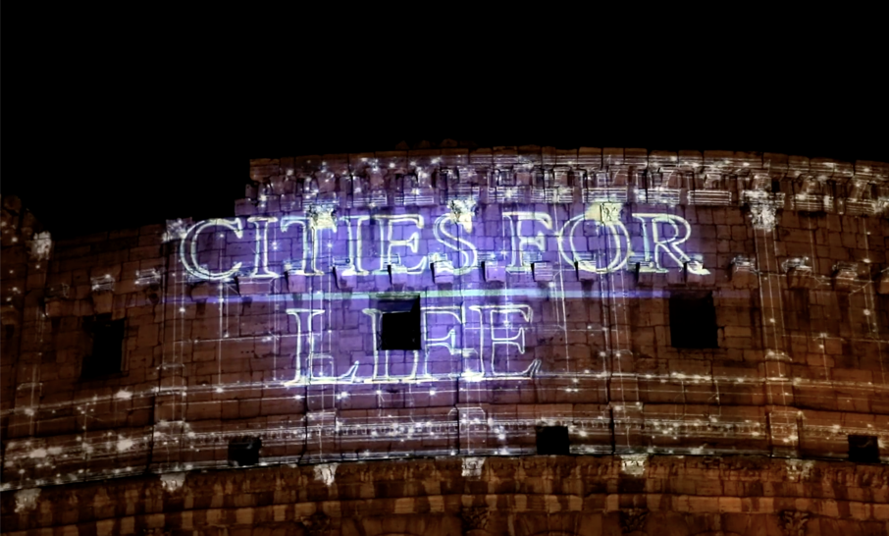  Urgent Actions  - An email was received from Reprieve asking for messages of support to be sent to the family of Hussein Abo al Kheir, who is at imminent risk of execution. He is a Jordanian labourer, sentenced to death for drug smuggling, a charge of which he was convicted following a confession obtained through torture. (Circulated to the Group and posted on the website, Facebook and Twitter 16.11.21.)  Campaigning  The December 2021 Update has not as yet been received – it will be forwarded and posted when it arrives.  Refugees  There has been much activity on the ongoing Nationality and Borders bill, which has reached the report stage, following the detailed discussion in committee, prior to going to the Lords. Follow the link for a full report* on the website on a number of issues of concern, including:  - The removal of citizenship without notification  - The points-based Immigration System  - Immigration as a concern for voters  - The Safe Return of Asylum Seekers  - Health Issues for Refugees  - Beyond Europe – the Migrant Protection Protocols aka Remain in Mexico  Thanks to AH for a very full report.  Note: Little Amal has arrived in Manchester.  UK Human Rights  Amnesty Progress of Reviews and Bills: Human Rights Watch Dec 2021  Independent Human Right Act  Independent Human Rights Act Review delivered its Report to the Lord Chancellor at the end of October 2021. As far as I have ascertained the Lord Chancellor has not yet responded.  Election Bill  No Change  Nationality and Borders Bill  No Change  Police, Crime, Sentencing and Courts Bill  No Change  Judicial Review and Courts bill  This Bill has moved quickly through the Commons and is now at the Report Stage.  Additional Information  - Police, Crime and Sentencing bill – Concerns have been raised about the way in which amendments are being introduced during the bill’s progress through the Lords. This results in the avoidance of scrutiny as MP’s are not allowed to discuss such amendments. Two amendments stand out –  - Stop and Search Powers – The Police would have the power to search people for ‘lock-on’ equipment, and to search anyone in the vicinity of a protest site for a 24-hour period without the need to justify stopping someone.  - Serious Disruption Prevention Orders – Control orders could be imposed on people who have taken part in disruptive protests. These orders would restrict movement, online posts, associates, and require people to report into a police station.  - A new bill – the Online Safety bill – raises concerns in that it would challenge the principle of freedom of expression but exempt politicians and the media from its impact. It is still in draft form and has not yet been submitted to the Commons. | LC  AH  MH
  House Of Commons | House of Lords | Final Stages
  1st reading  2nd reading  Committee stage  Report Stage  3rd reading | 1st reading  2nd reading  Committee stage  Report stage  3rd reading | Consideration of amendments  Royal Assent
  House Of Commons | House of Lords | Final Stages
  1st reading  2nd reading  Committee stage  Report Stage  3rd reading | 1st reading  2nd reading  Committee stage  Report stage  3rd reading | Consideration of amendments  Royal Assent
  House Of Commons | House of Lords | Final Stages
  1st reading  2nd reading  Committee stage  Report Stage  3rd reading | 1st reading  2nd reading  Committee stage  Report Stage  3rd reading | Consideration of amendments  Royal Assent
  House Of Commons | House of Lords | Final Stages
  1st reading  2nd reading  Committee stage  Report Stage  3rd reading | 1st reading  2nd reading  Committee stage  Report stage  3rd reading | Consideration of amendments  Royal Assent
5 | Social Media Report  Web and other media statistics, November 2021  Record month for the website with 944 views! The previous record was just broken in a month where that has been a lot of activity. There has also been an increase on the Facebook page.  Web site  The figures are:  Views  All time: 29,347.  Followers:  541 no change  Top country views:  Top posts:  Analysis: proportion of UK views is shown below:  Podcast  No podcast information available possibly because of service difficulties  Twitter  Impressions:  Followers: 205, no increase.  Facebook  Further improvement in interest this month again.  Top posts:  - Shamima Begum case  - Jagtar Singh Johal (India)  Tumblr  We have 9 followers and 19 following, small increase.  New! Instagram  We have 11 followers on Instagram. This is a new outlet and I shall be adding material here as time goes by.  Video  The North Korea video continues to clock up views 4,426 all time. Still image on Flickr: 5,665.  Group  Web site: www.salisburyai.com Twitter: www.twitter.com/salisburyai  Facebook: www.facebook.com/salisburyai Tumblr: www.salisburyai.tumblr.com  Instagram: https://www.instagram.co.uk/salisburyamnesty  If when looking at a post you like on the website or Facebook, don’t forget to click ‘like’! | PC
  May | June | July | Aug | Sept | Oct | Nov
  615 | 744 | 444 | 591 | 478 | 519 | 944
   | Nov
  USA | 709
  UK | 112
  Japan | 41
   | October
  1 | Group news
  2 | Death penalty report April 2009. (38 all time)
  3 | Liam Fox in Azerbaijan (114)
   | 2020 | Jan | Feb | Mar | April | May | June | July | Aug | Sept | Oct | Nov
  Total views | 6026 | 787 | 657 | 788 | 854 | 615 | 744 | 444 | 591 | 478 | 519 | 944
  UK views | 1758 | 106 | 81 | 132 | 146 | 71 | 64 | 32 | 42 | 61 | 49 | 112
  % | 29.2 | 13.5 | 12.3 | 16.8 | 17.1 | 11.5 | 8.6 | 7.2 | 7.1 | 12.8 | 9.4 | 11.9
  April | May | June | July | Aug | Sept | Oct | Nov
  877 | 176 | 316 | 620 | 714 | 445 | 1113 | 654
  April | May | June | July | Aug | Sept | Oct | Nov
  171 | 40 | 86 | 122 | 104 | 84 | 142 | 246
6 | Local Group Monthly Action  Follow the link for details of the items listed:  - Write for Rights  - Action for young girls forced into early marriage in West and Central Africa  - Amnesty activism during COP 26  - Invitation to become an Activism Rep (formerly Regional Reps.)  - Request for Financial Return Forms and appeal for funds  - Report and local action for Israel/Occupied Palestinian Territories *  - Opportunity to join two courses:  - Introduction to Equity & Inclusion  - Climate Change & Human Rights  *It was agreed that FD would order a campaigning pack for the Israel/Palestine action. | All  FD
7 | Urgent Actions  Follow the link for actions on behalf of:  - Zhang Zhan – a journalist imprisoned in China  - Lilia Chanysheva – an activist detailed in Russia on politically motivated charges and the former regional coordinator of ‘Navalny’s HQ’.  - Sultana Khaya – a Sahrawi woman activist in Morocco, raped and under house arrest.  - An imminent threat to peaceful protesters in Cuba. | All
8 | Write for Rights  A card signing took place at the Cathedral from 11.00 to 14.00 on Sunday 5th December. 97 cards were signed. It was agreed that being situated just outside the Refectory worked well. The Group ‘s thanks go to the Cathedral, and the helpful staff.  A second event will take place at St Thomas’s on the morning of Saturday 11th December. | FD  AH  All
9 | The Christmas Tree Festival at St Thomas’s – 30.11.21 – 5.12.21  It was agreed that the Group’s entry – ‘Spare this Tree’ - had been very effective. There had been no criticism, and it had been described as ‘amazing’ and ‘poignant’.  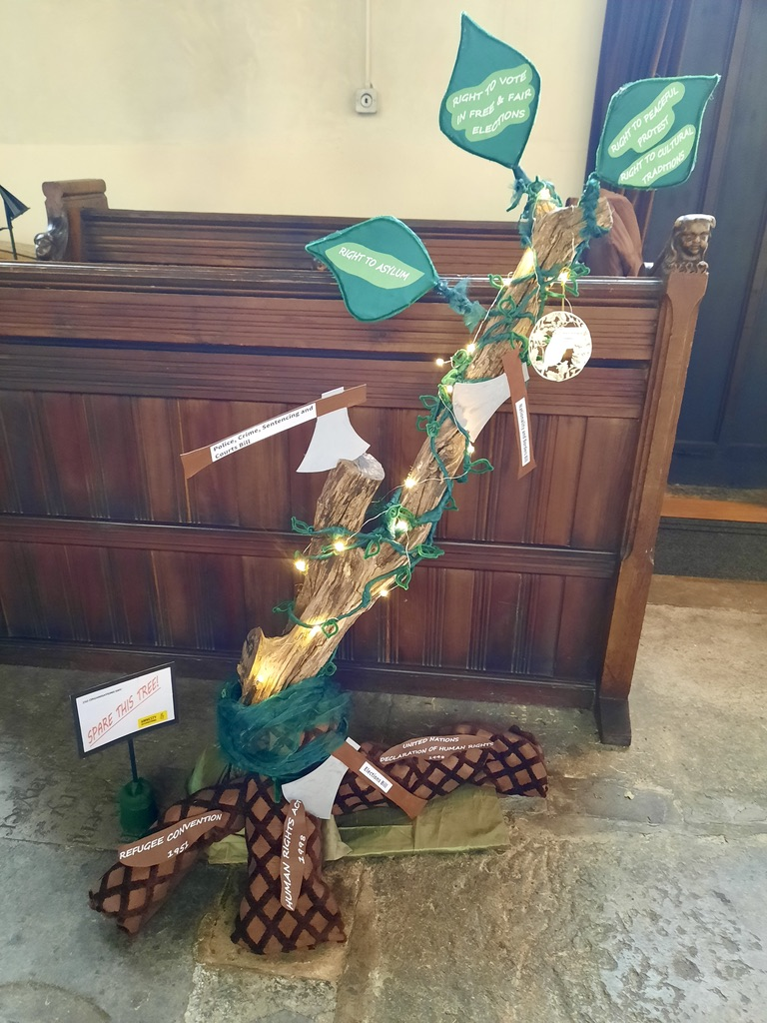  BBC Radio Wiltshire have invited exhibitors to let them know if they would like to participate in a new venture where they would be able to tell listeners about themselves. It was agreed that FD should respond and express interest. Note: They have replied to say they will contact her in the New Year. | PG  FD  RP  AW
10 | Carol Singing – Monday 20th December  FD has the authorisation for the house-to-house collecting, and will check with JD how many collectors are required, and ask him to bring the tins. She will also check the arrangements with CS.  Collectors are to be at 24 Victoria Road for 6.30 pm. | FD  TBC
11 | Cathedral Evensong.  There is no further news. It is hoped this could take place in Spring 2022. | AH
12 | Market Stall  Bookings are not being taken until the end of the year but the provisional date of Saturday 9th April is likely to be agreed. AH will complete the public liability insurance forms. | AH
13 | Arts Centre Film  FD will follow this up with the Arts Centre in the New Year. | FD
14 | Future Meeting Arrangements  With the recent development of the Omicron Coronavirus variant, it was agreed that – for the January meeting at least – the Group will continue to meet via Zoom. LC will send out the invitations.  MH will make enquiries with AIHQ as to whether there any ‘corporate’ arrangements for Local Groups’ to have access to their Zoom facility. | All  LC  MH
15 | Future Events  - Coffee Morning at St Thomas’s – to be investigated.  - Carol Singing – Monday 20th December – 6.30 pm  - Cathedral Evensong – TBC (Spring 2022?)  - Market Stall – Saturday 9th April? - TBC  - People in the Park – September?  - Arts Centre Film – TBC (Autumn 2022?) | All
Next Meeting: Thursday 13th January 2022
Time: 7.00 pm
Venue: Via Zoom – LC to send out invitations.

www.salisburyai.com www.twitter.com/salisburyai
www.facebook.com/salisburyai
Should you wish no longer to receive Minutes of meetings, or other communications from the Group, please let us know by emailing our Group Secretary at Donovan.fiona@gmail.com

