DEATH PENALTY REPORT: JULY – AUGUST 2022
UK Date format: day/month/year

The death penalty is the ultimate cruel, inhuman and degrading punishment. Amnesty opposes the death penalty in all cases without exception - regardless of who is accused, the nature or circumstances of the crime, guilt or innocence or method of execution.

International Report (from: 14.7.22 – 10.8.22)

- Gambia – 13.7.22 – Former Intelligence Chief Yankuba Badj and four other members of the Intelligence Services have been sentenced to death for the killing of the political activist Ebrima Solo Sandeng. Mr Sandeng, who had led a peaceful march, was beaten and tortured and died while in detention. (Source: Al-Jazeera.)

- Iran

  - 14.7.22 – Iran Human Rights (IHR) reports that, in the first half of 2022, executions have surged, doubling the total over the same period in 2021. At least 251 executions have been carried out from January to June of this year, compared to 117 in 2021. IHR have raised concerns that executions were being used to intimidate anti-government protesters, and that ethnic minorities were disproportionately targeted. (Source: Death Penalty Information Center.)

  - 27.7.22 – According to the Iran Human Rights Group, 32 people have been executed in the past week. Among them were three women, including a child bride, Soheila Abadi, convicted of the killing of her husband after marrying him 10 years previously at the age of 15. Activists say many of the cases involved accusations of domestic violence, which Iranian Courts frequently do not take into account. (Source: BBC News.)

- USA
  - New York State – 14.7.22 – Payton Gendron, who is accused of shooting and killing 10 people, who were Black, was indicted in Buffalo by a federal grand jury and charged with federal hate crimes. The Attorney General, Merrick Garland is considering the death penalty. (Source: ABC News.)

  - Mississippi – 15.7.22 – The State Supreme Court has denied the
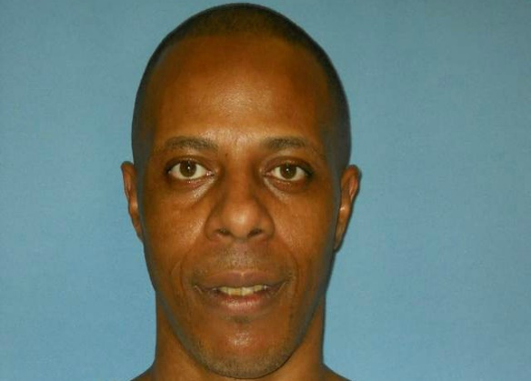
request of Willie Manning (left), a prisoner on death row, for additional DNA testing in a laboratory capable of more sophisticated testing than the one used at the time of the trial, where the results were inconclusive. Mr Manning, who is Black, was sentenced to death in 1994 for the murders of two White Students and in 1996 for a separate crime. He has maintained his innocence of both. He was exonerated of the 1996 conviction in 2015 when it was found that police and prosecutors had unlawfully withheld exculpatory evidence from the defence. (Source: Death Penalty Information Center.)

  - Oklahoma

    - 15.7.22 – Lawyers for James Coddington, scheduled to be executed on 25th August, following his conviction for the assault and killing of a friend, have filed a petition for clemency, citing his good behaviour throughout almost two decades in prison and the profound remorse he has shown for this crime. The case will be heard on 26th July. (Source: Death Penalty Information Center.)

    - 25.7.22 – Former Oklahoma Governor Brad Henry and former US Magistrate Judge Andy Lester, who co-chaired the Oklahoma Death Penalty Review Commission in 2017, have called for the halting of the scheduled executions of the 25 prisoners on death row. They have said, ‘It is high time to implement the numerous necessary reforms to make certain Oklahoma’s capital punishment system is beyond reproach.’ (Source: Death Penalty Information Center.)

    - 3.8.22 – In a 3:2 vote, the Oklahoma Board of Pardons and Parole have recommended clemency for James Coddington, and that his death sentence should be reduced to life without the possibility of parole. (Source: Death Penalty Information Centre.)

    - 9.8.22 – 44 Republican and 17 Democratic legislators have signed a letter to the State’s Attorney General to request a new hearing for Richard Glossip, sentenced to death for murder and scheduled to be executed next month. They have expressed concern that Mr Glossip could in fact be innocent as new evidence has come to light. His death sentence was imposed largely because of the testimony of the man who actually killed the victim but accused Mr Glossip of having ordered the killing. (Source: The Guardian.)

  - Alabama

    - 21.7.22 – The execution of Joe Nathan Jones, sentenced to death in 1996 for murder, is scheduled for 28th July. The two daughters and the brother of the victim have, however, called on Governor Kay Ivey to commute his sentence, saying neither they nor the Governor are God, and taking his life is not going to bring her back. (Source: Death Penalty Information Center.)

    - 28.7.22 – Mr Jones was executed by lethal injection, despite the opposition of the family of his victim. (Source: The Guardian.)

    - 8.8.22 – Mr Jones’s sister has called for an investigation into his botched execution following a statement by the Department of Correction’s spokesperson that the Department could not confirm that he was fully conscious when he was executed. (Source: Death Penalty Information Center.)

  - South Carolina

    - 26.7.22 – The US Court of Appeals for the Fourth Circuit overturned the death sentence of Quincy Allen for murder having found that the Sentencing Judge had ignored uncontested evidence of his mental illness and history of severe childhood abuse and neglect. (Source: Death Penalty Information Center.)

    - 1.8.22 – Follow the link for an article on an investigation by Greenville News which found that the State’s death penalty cases were ‘plagued with issues, including misconduct and improper evidence’ (Source: Greenville News.)

    - 1.8.22 – Follow the link for an article providing a ‘a look at the legacy of racism and bias in the death penalty as the State fights to keep it.’ (Source: Greenville News.)

    - 1.8.22 – The trial to debate the constitutionality of the State’s recently imposed death penalty statute has begun. The statute would make the electric chair the default method of execution, and a firing squad the second option. A civil lawsuit, filed on behalf of Richard Moore, Freddie Eugene Owens, Brad Sigmon and Gary Duboose Terry, alleged these methods were prohibited by South Carolina’s Constitution as cruel, unusual and corporal punishment. (Source: Greenville News.)

  - California – 27.7.22 (date of post) – From late June to mid-July, State and Federal Courts have overturned the death sentences of three prisoners – Richard Clark, Michael Bramit and Andrew Lancaster – because of claims related to Defense Counsel’s inadequate performance or jury-related issues. New penalty-phase trials will take place for Mr Clark and Mr Bramit. Mr Lancaster ‘s death sentence has been vacated. (Source: Death Penalty Information Center.)

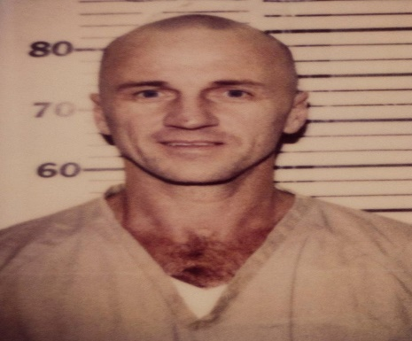
  - Michigan – 6.8.22 – The appeal of Marvin Gabrion against his death sentence has been rejected. Mr Gabrion was convicted of first-degree murder, and had appealed on the basis that he was mistreated by the justice system. He is the only prisoner on death row in the State and has now exhausted the direct appeals system. (Source: MLive.com.)

  - 10.8.22 – Follow the link to information on the annual report of the American Bar Association’s Criminal Justice Section – The State of Criminal Justice 2022 – which examines the state of the American Legal system and of the death penalty in the US. It concludes that capital punishment could see a fundamental change because of a combination of pre-pandemic trends, a backlash against the federal executions at the end of the Trump presidency, and significant changes to the composition of the US Supreme Court. (Source: Death Penalty Information Center.)

- Singapore – 22.7.22 – Following the imposition of the mandatory death sentence for drug-related offences, Nazeri bin Lajim was executed. This was the fifth execution to be carried out following a pause of over two years following the Pandemic. Chiara Sangorgio, Amnesty’s death penalty expert, condemned the ‘relentless wave of hangings’, and called on Governments, the UN Office on Drugs and Crime, and the International Narcotics Control Board ‘to increase pressure on Singapore so that international safeguards on the death penalty are respected and drug control policies are rooted in the promotion and protection of human rights.’ (Source: Amnesty International.)

- Pakistan – 23.7.22 – A High Court Judge has said there were no eyewitnesses linking a British woman with the killing of her businessman husband. Yasmin Kauser had been held in a prison in Pakistan, awaiting trial, and could face the death penalty. Mrs Kauser has always proclaimed her innocence. Released on bail, she said she was beaten by police offers, trying to force a confession out of her. Now back in the UK, she has been told it could take 18 months for the case to be concluded. (Source: The Mirror.)

- Burma – 25.7.22 – The Junta-controlled media reported that four executions had taken place, including those of Phyo-Zeya Thaw, a rapper and former lawmaker from the Party of Aung San Suu Kyi, and Kyaw Min Yu (Ko Jimmy), a prominent democracy activist. They had been accused of conspiring to commit acts of terrorism, and their death sentences had followed closed trials. Hia Myo Aung and Aung Thura Zaw, who had been involved in protest movements, and had been accused of killing a suspected informant, were also executed. According to the UN, these were the first executions to have taken place for over 30 years. It is understood that, since the coup, 76 prisoners have been sentenced to death, including 2 children, with a further 41 people sentenced in absentia. (Source: The Guardian.)


Japan – 26.7.22 – The execution has taken place of Tomohiro Kato, sentenced to death in 2011 for running a truck into a Tokyo shopping district and stabbing a number of people. Seven people were killed and ten injured. Despite growing international criticism, Japan has continued to use the death penalty. (Source: ABC, pic: Murderpedia.)

- The Guardian – 27.7.22 – Follow the link for an editorial in the newspaper on the current world-wide situation regarding capital punishment. This notes the broad trend towards decline, but highlights the ‘horrifying exceptions’ of Oklahoma and Burma, together with references to the resumption of federal executions under Donald Trump’s administration, the secrecy around the high numbers in China, Vietnam and North Korea, and the many issues around the actual application of the death penalty. It states ‘But underlying all of this is the broader understanding that continues to spread through the world: that states have no right to take the lives of citizens’. (Source: The Guardian.)

- Russia/Ukraine – 10.8.22 – Russian scientists and human rights activists have called President Putin to halt the death penalty and extend the moratorium to the Donetsk’s People’s Republic. (Source: The Moscow Times.)

Follow the link for an article from Fair Planet about the death penalty and abolition.

Urgent Actions

- USA – Texas – On 3.8.22 AIUK advised local groups that the Texas Court of Criminal Appeals had stayed the execution of Ramiro Gonzales, and no further action was required. (Circulated to the Group on 3.8.22.)

Campaigning

- Follow the link for the Anti-Death Penalty Project newsletter for July, which contains information on:

  - The executions in Burma/Myanmar – the first in decades;
  - Singapore’s return to the use of the death penalty with the execution of Nazeri bin Lajim;
  - The scheduling of 25 executions in Oklahoma – the US State second only to Texas in the number of executions carried out;
  - A video clip on the wrongful convictions of two prisoners on death row -Nathaniel Woods who was executed, and Ray Hinton who was exonerated following 28 years on death row.

- World Day Against the Death Penalty – 10th October 2022

  - Follow the link for Testimonies – Acts of Torture in Capital Punishment – a document compiled by the Secretariat of the World Coalition Against the Death Penalty, with substantial aid from member organisations, including Amnesty International. The use of torture in capital punishment – physical, mental and its effects on the families – is the theme for this year’s world action.

  - An email has been sent to the Anti-Death Penalty Project asking for advance notice of any national Amnesty action planned for the World Day. Should this not be forthcoming, a letter writing/email action will be identified for the group, members and supporters shortly beforehand. This would be disappointing as – with Covid-related restrictions having been removed – the Group were hoping participate in a wider action.

