DEATH PENALTY REPORT: MARCH – APRIL 2024
UK Date format: day/month/year

The death penalty is the ultimate cruel, inhuman and degrading punishment. Amnesty opposes the death penalty in all cases without exception - regardless of who is accused, the nature or circumstances of the crime, guilt or innocence or method of execution.

International Report (from: 13.3.24 – 9.4.24)

- Kenya – 13.3.24 – Joseph Irungu, popularly known as ‘Jowie’, who had worked as a Security Officer and provided VIP security for a number of politicians, has been given a death sentence following his conviction for murder. (Source: Capital News and BBC.)

- USA

  - Tennessee – 13.3.24 – Jessie Dotson, sentenced to death following his conviction for the killing of six people, has filled a petition asking for his conviction and death sentence to be vacated. He alleges his innocence, and police coercion to a false confession, together with a number of prosecutorial and defence errors. (Source: Death Penalty Information Center.(

  - Georgia

    - 15.3.24 – The State Board of Pardons and Paroles is to conduct a clemency meeting on 19th March for Willie Pye, whose execution is scheduled for 20th March. (Note: The execution period extends to 27th March.) Following the meeting, the Board may commute his death sentence to life imprisonment, with or without the possibility of parole, issue a stay or deny clemency. (Source: State Board of Pardons & Paroles.)

    - 19.3.24 – The Clemency Panel deliberated for several hours but clemency was denied. (Source: The Independent.)

    - 20.3.24 – Willie Pye, who had an intellectual disability, underwent a troubled upbringing, and received ineffective assistance from his Defence Counsel, was executed by lethal injection. This was the first execution to take place in Georgia since 2020. (Source: CNN.)

  - California

    - 27.3.24 – Prisoners on death row at San Quentin Prison are being transferred to other prisons in the State as Governor Newson puts into action his plan of reinventing the facility as a rehabilitation centre. 70 of the 532 have already been moved. Follow the link to the article from the BBC describing the fears of many of the prisoners, who will still be under sentence of death – the executive order by Governor Newsom in 2019 halted the use of the death penalty, but this could be reversed by an incoming Governor. The prisoners have little access to rehabilitation programmes and will need to cope with a new environment, often after many years at St. Quentin. (Source: BBC News.)

    - 5.4.24 – District Attorney Jeff Rosen is seeking to change the death sentences of 15 prisoners into life imprisonment without parole. He said he had lost faith in the death penalty as an ‘antiquated, racially biased and error prone system that deters nothing and costs us millions of public dollars and our integrity as a community that cherishes justice’. The State has not used the death penalty since the murder of George Floyd. (Source: Office of the District Attorney.)

  - The Use of the Death Penalty in the US – 19.3.24 – Follow the link for an article from the Editors of Scientific American highlighting the fact that numbers of studies show that ‘the death penalty does not deter crime, puts innocent people to death, is racially biased, and is cruel and inhumane.’ (Source: scientificamerican.com.)

  - Federal Death Penalty – 21.3.24 – The 1st US Circuit of Appeals ordered the Judge who presided over the trial of Dzhokhar Tsarnaev – convicted of the Boston Marathon Bombing – to investigate Mr Tsarnaev’s defence attorney’s claims of juror bias and to determine whether his death sentence should be overturned because of this bias. (Source: Death Penalty Information Center.)

  - Alabama – 24.3.24 – More than 40 members of Amnesty International USA marched to the State Capitol calling for clemency for Rocky Myers, sentenced to death by judicial override of the Jury’s sentence. A rally also took place in support of House Bill 27 which, if passed, would make the law prohibiting judicial override retroactive, and thus apply to Rocky. (Source: Alabama Daily News.)

  - Annual Report – National Registry of Exonerations – 25.3.24 – Follow the link for an article by the DPIC, together with a link to the report on exonerations in 2023, which shows that of the 153 exonerees, 93 were Black, and that prosecutorial misconduct was the most frequent factor in their wrongful conviction. (Source: Death Penalty Information Centre.)

  - Missouri

    - 26.3.24 – A discussion took place regarding the possible repeal of the bill allowing a Judge to impose a death penalty when the Jury is ‘deadlocked’. Missouri and Indiana are now the only States that allow this. Brian Bernskoetter from the Missouri Organisation of Defence Lawyers spoke in favour of the repeal and said he believed the State was moving away from the death penalty as policy – ‘We have seen that it isn’t as effective as a deterrent as it was meant to be’. (Source: KY3.)

    - 4.4.24 – More than 150 people – including more than 70 current and former prison workers, together with Republican state representatives, jurors and the Appeals Judge who previously upheld his death sentence – have called on Governor Mike Parson to commute Brian Dorsey’s execution to life imprisonment without parole. The execution of Mr Dorsey, who was convicted of the killing of his cousin and her husband, is scheduled for 9th April. (Source: The Guardian)

    - 9.4.24 – The execution by lethal injection took place of Brian Dorsey, despite the many calls for clemency. On Tuesday 8th, Governor Mike Parson had denied a last minute appeal for a stay, followed by the US Supreme Court’s decision not to intervene. (Source: The Guardian.)

  - Texas – 27.3.24 – The Texas Court of Criminal Appeals re-sentenced Randall Mays, sentenced to death in 2008 for killing two Deputy Sheriffs, to life in prison without parole. In 2019 the plan to execute Mr Hays was halted following concerns regarding his understanding of his actions. The IQ of Mr Mays has been assessed as 68. Note: Different States employ different standards for such assessments, and federal oversight appears to be limited. (Source: Mother Jones.)

  - Oklahoma

    - 28.3.24 - Judge Michael Hogan ruled that James Ryder was incompetent to be executed following a hearing where experts established his serious mental illness. His attorney stated that Mr Ryder had no rational understanding of why the State planned to executed him and had had schizophrenia for almost 40 years. Mr Ryder had been convicted of two murders. (Source: Death Penalty Information Centre.)

    - 4.4.24 – The execution took place by lethal injection of Michael Dewayne Smith, who had been convicted of the murders of two people. His lawyers had insisted he was not responsible, and had appealed for clemency on the grounds of a former abuse problem and an intellectual disability. (Source: CBS News.)

  - Ohio – 8.4.24 – Follow the link for a post from the DPIC on the 2023 Capital Crimes Report issued by the State’s Attorney General Dave Yost. This highlights numerous problems with its ‘broken’ capital punishment system, including the ‘enormously expensive cost’. (Source: Death Penalty Information Center.)

  - Death Penalty in the US - 9.4.24 –

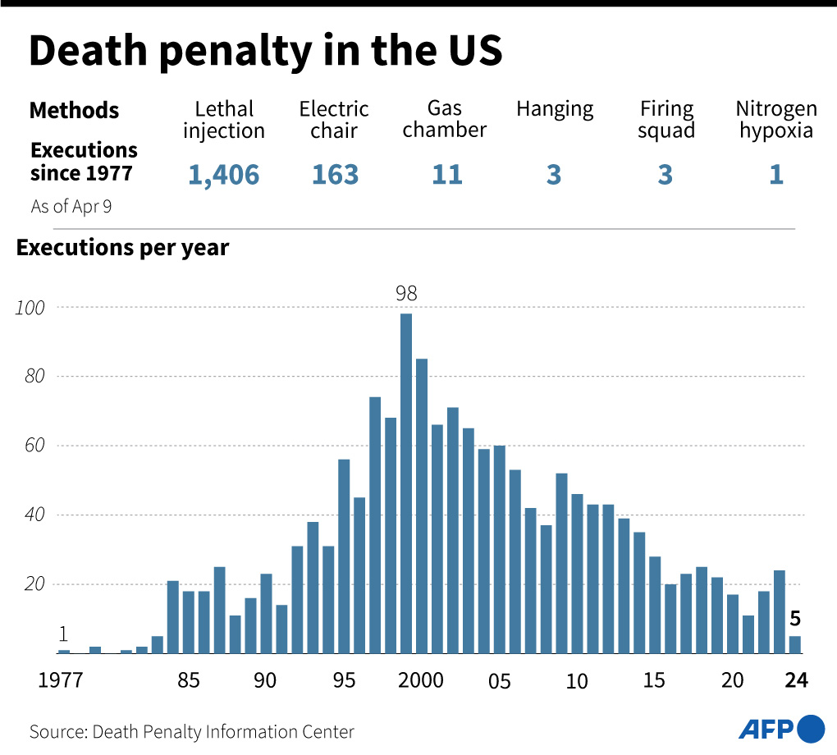
(Barron’s/DPIC)

- Congo – 15.3.24 – The moratorium on the death penalty, imposed in 2003 has been lifted, with the Authorities claiming this is necessary because of ‘violence and militant attacks’. They are referring to increasing violence, particularly in Eastern Congo, where rebel groups such as M23 have attacked villages. A Ministry of Justice spokesperson has said capital punishment will be imposed on offenders involved in criminal conspiracies, armed gangs and insurrection, those who commit treason and war crimes and military personnel who, rebel, desert or join enemy ranks. The decision has been condemned by Human Rights Groups. (Source: AP News.)

- Thailand/UK – 17.3.24 - A British man, Charly Garcia, has been accused of dealing in drugs, and could face the death penalty.

- Pakistan – 20.3.24 – Two women have been sentenced to death for the murder of their religious school teacher who they accused of committing blasphemy following a dream by another pupil. According to Amnesty International, no executions have taken place in Pakistan since 2020 but many female prisoners remain on death row for years. (Source: Al-Jazeera.)

- Russia

  - 24.3.24 – A number of senior members of President Putin’s regime have called for the re-introduction of the death penalty, following the attack two days previously on the concert hall in Moscow, when more than 130 were killed and others injured. Critics have expressed alarm, citing the country’s broad use of counter-terrorism and other anti-extremist laws. Note: A moratorium on the death penalty has been in existence since the 1990’s. (Source: Barron’s.)

  - 25.3.24 – The Kremlin have said they are not at the moment taking part in discussions about the reinstatement of the death penalty. The penal code currently allows the death penalty to be imposed for five offences – murder, genocide and the attempted murder of a Judge, Police Officer or State Official. (Source: Reuters.)

  - 31.3.24 – It has been reported that President Putin is considering allowing the trial of the suspects to take place in Belarus, where they could face the death penalty. (Source: MSN.)


- UK – 26.3.24 – A British Court ruled that Julian Assange cannot be extradited to the US to face charges of espionage unless the authorities guarantee he would not face the death penalty, thus being afforded the same protections as an American citizen. Should this assurance not be given over the next three weeks, Mr Assange will be granted a new appeal. (Source: ABC News.)

- Afghanistan – 28.3.24 – The Leader of the Taliban announced that it is to resume publicly stoning women to death for adultery. Women’s rights groups in the country have expressed shock but not surprise, saying the dismantling of any rights and protections for women and girls was now almost complete. Samira Hamidi, activist and campaigner with Amnesty, said Afghan women were now powerless to defend themselves from persecution and injustice. (Source: The Guardian.)

- Uganda – 2.4.24 – The Constitutional Court upheld the law allowing for the death penalty to be imposed on those convicted of ‘aggravated homosexuality’, which is defined as cases of homosexual relations involving a minor or other categories of vulnerable people, or when the perpetrator is infected with HIV. Homosexuality is criminalised in more than 30 African countries. (Source: NBC News.)

- Worldwide International Roundup – 3.4.24 – Follow the link for information on Afghanistan, DRC, India, Iran, Nigeria, Pakistan, Russia, Saudi Arabia and the United States. (Source: Death Penalty Information Centre.)

- Iran – 4.4.24 – Follow the link for a research briefing published by Amnesty highlighting the fact that more than half of the total executions recorded in 2023 (481 of 853) were for drug-related offences. The total number of executions was the highest recorded since 2015, marking a 172% increase from 2021, and included protesters, social media users, and those accused of ‘apostasy’, ‘enmity against God’ and/or ‘corruption on earth’. (Source: Amnesty International.)

- World Coalition Against the Death Penalty – 4.4.24 – Follow the link for this month’s Newsletter which contains information on:

  - President Biden and the death penalty;
  - Armenia’s ratification of Protocol 13;
  - The unprecedented shift in attitudes towards abolition in the US
  - The death penalty in Singapore;
  - Women and the death penalty in Kenya
  - Information on new members;
  - New documents;
  - Important dates.

- China – 8.4.24 – Three boys, who were under 14 at the time, have been accused of the murder of a fellow pupil and could face the death penalty. The age of criminal responsibility in the country was lowered in 2021 from 14 to 12 for ‘special cases’ such as causing death by ‘extremely cruel means’. (Source: Mail Online.)

- Serbia – 8.4.24 – Following the murder of a two-year-old child, President Aleksandar Vucic has called for the re-introduction of the death penalty. (Source: Novinite.com.)

Urgent Actions

- An Urgent Action was received from AIUK on behalf of Rocky Myers, calling for social media messages to be sent to Governor Kay Ivey on 21.3.24 (see below.) (Circulated to the Group 20.3.24.)

Campaigning

- Amnesty Anti-Death Penalty Campaign - Follow the link for this month’s Newsletter, which contains information on:

  - An action co-ordinated with AI USA on behalf of Rocky Myers was to take place on 21st March. It is of concern that the request was only received from AIUK on 20th March, so no time for letters, but members and supporters were asked to contact Alabama Governor Kay Ivey via social media calling for Rocky’s death sentence to be commuted.

  - The reinstatement of the death penalty in DRC.

  - The sentencing to death for blasphemy of a student in Pakistan, together with details of the laws and how they have been implemented.

  - The execution of Ivan Cantu in Texas.

  - The botched attempts to execute Thomas Creech in Idaho.

  - The call by a former Conservative MP for a debate in the Commons on the reinstatement of the death penalty in the UK for ‘crimes against humanity’.

  - A video of a prisoner and his brother talking about receiving a death sentence and watching an execution.

  - A death penalty fact regarding Oklahoma.

