Amnesty International Salisbury Group

Minutes of the Monthly Meeting on Thursday
12th December 2024 at 2.00 pm - 4 Victoria Road
1 | Chairman’s Welcome  Present: EB, TM, FD, AH, VJ, PC, LC  Apologies: JN, MH | AH
2 | Minutes of Previous Meeting – These were agreed. | LC
3 | Matters Arising – There were none.
4 | Treasurer’s Report – Bank - £1,162.43  Cash - £30.06  Note: The Carol Singing raised £514.66; Expenses for Write for  Write for Rights totalled £97.60. | MP
5 | Campaign Reports  Death Penalty  Please see the Salisbury Group Website for the full International Update covering The USA, Saudi Arabia, the EU, Thailand, Singapore, France/Indonesia, Iran, Vietnam and India, together with a Worldwide Roundup with information on China, Iran, Saudi Arabia, Singapore and Vietnam.  Of particular interest –  - In the USA  - Executions - Two executions have been carried out – in Alabama Carey Grayson was executed by nitrogen gas on 21.11.24, and in Missouri Christopher Collings died by lethal injection on 3.12.24.  - Scheduled/pending Executions  - In Indiana Joseph Corcoran, who has paranoid schizophrenia, is scheduled to die on 18th December. He would be the third ‘volunteer’ to be put to death – a volunteer is a prisoner who takes affirmative steps to hasten their execution, including waiving appeals, asking for an execution date, or instructing their attorneys not to file end-stage litigation.  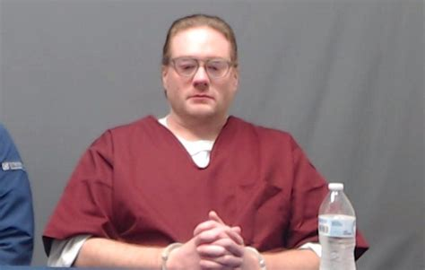  - In Oklahoma Kevin Ray Underwood (pictured – pic: Yahoo) is scheduled to be executed on 19th December. Two meetings with the Pardon and Parole Board to appeal for clemency have been cancelled. The Board does not have its full complement of members, and his lawyers argue this would violate his due process rights.  - In Texas the latest ruling of the Texas Supreme Court is that the execution of Robert Roberson (shaken baby syndrome) can go ahead, but a House Committee has issued another request for Mr Roberson to be enabled to give his testimony.  - In Idaho the final appeal by Thomas Creech has been dismissed by the State Supreme Court. (Mr Creech suffered an earlier ‘botched’ execution attempt when officials were unable to find a suitable vein.) The Federal Court will decide whether a new date can now be set.  - Watching brief  - In Texas a Democratic State Representative has filed a bill that would eliminate the State’s death penalty.  - In Pennsylvania a bill has been introduced that would impose the mandatory death penalty on ‘illegal aliens convicted of murder’.  - The State of Arizona expects to reinstate executions in 2025 following a two-year halt for a review of the process.  - In Illinois a call has been issued for the death penalty to be imposed on those convicted of killing a law enforcement officer.  - Federal Death Penalty – Serious concerns have been expressed at the likelihood of President Trump’s second presidency seeing a return to the federal ‘execution spree’ that took place towards the end of his first presidency. Numbers of advocates, civil and human rights associations and religious leaders – including Pope Francis – have called on President Biden to commute the death sentences of all those on federal death row before he leaves office.  - Reports & Research  - Follow the link for an article from the Brennan Centre of Justice clarifying the background to the federal use of the death penalty, which highlights influential factors such as geography, race and legal representation, together with issues around the treatment of those with intellectual disabilities or mental illness, the pain and suffering caused by the process and miscarriages of justice. (Source: Brennan Centre for Justice.)  - A survey conducted by Gallup in October 2024 shows support for capital punishment remains at a 5-decade low in the US. Overall, it was found that 53% of Americans are in favour, but there are considerable differences between those older and those younger and, amongst those expressing a political affiliation, support for the death penalty fell markedly in all groups and generations, with the exception of Republicans aged 60 or older. Follow the link for full details. (Source: Death Penalty Information Center.)  - Follow the link for a post from the DPIC on the effect of executions on the mental health of prison staff. Note: This includes reference to Oklahoma. (Source: Death Penalty Information Center.)  - In Saudi Arabia reports indicate that 101 foreign nationals have been executed in 2024, three times the numbers in 2022 and 2023. These include 21 from Pakistan, 20 from Yemen, 14 from Syria, 3 from Sudan, 3 from India, 3 from Afghanistan, 1 from Sri Lanka, 1 from Eritrea and 1 from the Philippines. The total of executions to date in 2024 is 274, 92 of which 92 were drugs-related. According to Amnesty International, the Kingdom of Saudi Arabia had the third highest figures of any country, following China and Iran. On December 11th, FIFA awarded Saudi the right to hold the World Cup in 2034 despite human rights violations and many other problems.  - In Singapore three executions have been carried out this month, bringing the total to date in 2024 to eight. All have been in relation to drugs-related offences.  - In Iran  - Toomaj Salehi, the rapper who was sentenced to death in 2022 following his public support for the protests at the death of Mahsa Amini, has been released from prison. His death sentence had been overturned in June but he had remained in prison to serve a sentence imposed for ‘propaganda against the State’.  - There are reports that six members of the Iranian dissident group – The People’s Mojahedin Organisation of Iran – have been sentenced to death. (Formerly listed as a terrorist organisation by the US and EU, since 2012 this has no longer been the case.)  Urgent Actions  - An Urgent Action with a petition was received from Amnesty for Pannir Selvam Pranthaman, one of several Malaysians currently on death row in Singapore. Mr Pranthaman is at imminent risk of execution following his conviction and death sentence almost 10 years ago for importing 51.84 grams of diamorphine. (Circulated to the Group 30.11.24.)  - An Urgent Action was received from Amnesty Canada for Joseph Corcoran, whose execution in Indiana, USA is scheduled for 18th January. See above and follow link for details. (Forwarded to Group 8.12.24.)  Campaigning  - Amnesty Anti-Death Penalty Project – Follow the link for this month’s Newsletter, which contains information on:  - North Korea and its public execution of prisoners;  - Burkina Faso and its proposal to reintroduce the death penalty;  - The death of Jamshid Sharmahd, the Iranian-German dissident;  - An article on Robert Roberson, due to be executed following his conviction based on the discredited Shaken Baby Syndrome;  - The impact of US Presidential elections on federal and military executions;  - The ‘Adopt a Governor’ Campaign;  - Executions in Saudi Arabia;  - A death penalty video by Clive Stafford Smith.  - The Oklahoma Campaign – This involves contacting the Governor of Oklahoma calling for the end of the death penalty in the State.  - The November action involved writing or emailing Governor Stitt focusing on the racial discrimination in the death penalty as it is applied in Oklahoma.  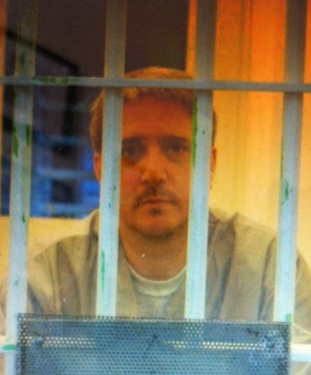  - For December, members and supporters are asked to send a Christmas card to Richard Glossip. Mr Glossip is under sentence of death and is awaiting the outcome of a review by the US Supreme Court. Their decision is not expected until Summer 2025.  Cards to be sent to: Richard E Glossip  # 267303  O.S.P.H – Unit SW3 FF  PO Box 97  McAlester  Oklahoma 74502  USA.  Please note: no glitter or parts that have been ‘stuck on’.  It was agreed that, rather than planning a specific  action for January, the Group would monitor the  situation of Kevin Ray Underwood, whose execution  is scheduled for 19th December, and send appeals  to the Governor should the Pardon & Parole Board  meet and the execution date be confirmed.  Refugees report  - To begin with more positive news, the collapse of the regime in Syria has led to a rush among exiles to return to the country. Refugee camps just outside Syria have been particularly active. The downside is that, as a result, European governments (including the UK) have paused processing active asylum claims from Syrians. The UNHCR has calculated that the largest number of refugees from Syria leaving for other countries under Bashar al-Assad were Turkey 3.1 million, Lebanon 774,000. Germany 717,000 and Jordan 628,000.  - Statistics released this month indicate that the net migration totals for the UK have dropped to 728,000 for year ending June 2024 but, of course, most of these are legal. Of the asylum claimants, the backlog of cases was at 97,200 in September, mostly appeals, as the percentage of claims granted by the Home Office has fallen over the last 12 months from 75% to 52%. At the same time, it has been said that only 52% of asylum decisions have met the Home Office’s internal quality assurance requirements. Since the Home Office has imposed a 2-hour limit on interviews with claimants in an attempt to speed things up, this is perhaps not surprising.  - Small boats arrivals have dropped substantially in the last month, due mainly to adverse weather. No boats arrived between 17th and 30th November, and only 8 since, which means 400 arrivals in the last 3 weeks. Greece, the main point of entry to Europe for many, has received 57,000 arrivals this year so far.  - A change in the law means that newly accepted asylum seekers in the UK will now have 56 days to ‘move on’ from asylum accommodation, twice the previous limit. The Home Office is also planning to house asylum seekers in disused care homes and student accommodation. The National Audit Office has concluded that accommodation like military bases and barges do not represent value for money.  - Britain has signed a deal with Iraq to tackle people smuggling gangs, particularly in the Kurdistan region. Deals with other front-line countries may follow. Meanwhile the UK and Germany have pledged to share intelligence and expertise against the gangs. Germany will make it a specific offence to facilitate smuggling migrants to the UK; many of the rubber dinghies are stored in Germany.  - Refugee Week 2025 – Next year’s theme will be Community as a Superpower. The possibility of a community-based event was discussed, and could be a positive way of using some of the Group’s funds. AH will contact local refugee and church groups.  UK Human Rights  FD briefly updated the Group on the response of Elena Auer’s Collective for Human Rights in the UK to an invitation from the cross-party Parliamentary Modernisation Committee to register concerns/ideas relating to Parliamentary procedure.  Concerns included:  - Reform of the ballot system  - More time for private members’ bills  - Lack of transparency about vested interests  - Recent over-use of strategic instruments.  Suggestions were:  - Reform of the ballot system  - More time for private members’ bills  - An independent watchdog with enforcement powers  - More scrutiny of ex-civil servants in secondary employment and advisory roles  - Publication of ministers’ meetings with outside interests, and of complaints and the actions to redress them  - The independence of the Parliamentary Commission for Standards  Follow the link for an article from EachOther on the plans for major policing reforms announced by the Home Secretary, Yvette Cooper, at the National Police Chief’s Council and Association of the Police & Crime Commissioners annual conference on 20th November. | LC  AH  AH  FD  LC
6 | Social Media Report  We had 216 views in the month with particular interest in the Tinderbox film and our 50th anniversary supper. The 48th Vigil was much viewed as well. Most views came from the UK with the US second.  Subscribers were interested in the urgent action in Oklahoma. That we are no longer on X was of interest and a group news item third.  We have nearly 48,000 all-time views.  There has been an increase in interest in Facebook with Vigil number 48 also of most interest. The anniversary supper was second and another Vigil, the 51st third.  Note: we are now on BlueSky and Mastodon. Readers are invited to click on these and put them in favourites to give a quick reference to the group’s posts. | PC
7 | Local Groups  Follow the link for this month’s Local Groups Update, which contains information on:  - The new Local Groups Administrator – Philippa – with a request for Group updates and photos by 24th January;  - Write for Rights 2024;  - A webinar on Sexual and Reproductive Health Services in Sudan’s Conflict which took place on 2nd December;  - The screening of the documentary ‘She’s in Jail’ and solidarity action with HR defenders in Hong Kong on 14th December;  - An invitation to host the exhibition ‘Surviving Erin’ which tells the story of Anoosheh Ashoori from his time in prison to his release:  - Learning at Amnesty  - Digital Training Survey for proposed Training Workshop  - In Conversation of Sacha Deshmukh  - November Fundraising Update;  - Upcoming Dates;  - Actions from Across the Amnesty Movement;  - Local Group Events;  - New Amnesty Shop Catalogue.  Follow the link for this month’s Urgent Actions which include actions for:  - Joseph Corcoran, whose execution in Indiana, USA is scheduled for 18th December;  - Dr Kizza Besigye, an opposition politician arraigned in a military court in Uganda;  - Journalists in Kyrgyzstan;  - Anas al-Bellagy an unjustly jailed politician’s son in Egypt. | All
8 | Amnesty Group 50 Year Tree Planting  FD informed the Group that she had sent the logo but as yet had received no information on pricing. The planting is expected to take place in December/January. | FD  All
9 | Write for Rights  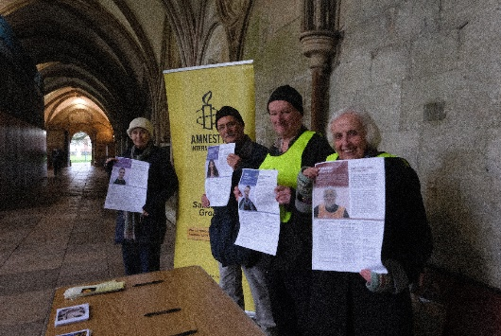  53 cards had been signed at Bishops, and 84 at the Cathedral – a total of 137. It may be possible to take the cards to the second session at the school (see below.)  Following advice from the Cathedral, next year’s Write for Rights will take place from 12.00 midday to 3.00 pm, and has been booked for 30th November 2025. | FD  All
10 | Schools Visits.  The first session on 26th November went well. The second (of three) with a different group has been arranged for 23rd January | FD  AH
11 | Vigils  These are to continue until further notice on Saturdays from 5.00 to 5.30 pm. FD will write to CS to say members of the Group will attend and help, but would prefer those attending to bring their own materials. | All who  wish  FD
12 | Carol Singing  Many thanks to the Farrant Singers, who sang the carols, and to CS and her family who hosted. £514.66 was collected. | FD  All
13 | Evensong  AH will contact the Cathedral in the New Year and suggest a date in March or April 2025. | AH  All
14 | AOB  - The Group briefly discussed Amnesty’s report concluding that Israel was committing genocide against Palestinians in Gaza.  - A brief discussion was also held on the report in The Salisbury Journal on 1st December on the event at Salisbury Cathedral in which two great-grandchildren of a Nuremberg prosecutor had sung about the European Convention. It was regretted that the Cathedral had not informed or included the local Amnesty Group. | All
15 | Forthcoming Events  - Cease Fire & Peace Vigils – Saturdays until further notice 5.00 to 5.30 pm  - Talk at Bishops – 23rd January 2025  - Evensong at the Cathedral – TBA  - People in The Park – 17th May 2025  - Coffee Morning at St Thomas’s – 5th July 2025  - Write for Rights – 30th November 2025 | All
Next Meeting: Thursday 9th January 2025
Time: 2.00 pm
Venue: 4 Victoria Road

www.salisburyai.com Mastodon, Bluesky,

Should you wish no longer to receive Minutes of meetings, or other communications from the Group, please let us know by emailing our Group Secretary at Donovan.fiona@gmail.com

