 | Amnesty International Salisbury Group  Minutes of the Monthly Meeting on Thursday 8th May 2025  2.00 pm - 24 Attwood Road | 
1 | Chairman’s Welcome  Present: FD, VJ, EB, PC, LC  Apologies AH | FD
2 | Minutes of Previous Meeting – These were agreed | LC
3 | Matters Arising – There were none. | FD  All
4 | Treasurer’s Report - Bank – £760.07  Cash - £30.06 | MP
5 | Campaign Reports  Death Penalty  Please see the Salisbury Group Website for the full International Update covering The USA, Iran, Tunisia, Saudi Arabia, Israel and Vietnam, together with an article from the DPIC on Pope Francis as an advocate for the abolition of the death penalty and one from the WCADP on Amnesty’s 2024 Global Report.  Of particular interest –  - In The USA  - Executions – 4 scheduled executions have been carried out:  - In South Carolina on 13.4.24 Mikal Mahdi by firing squad  - In Texas on 24.4.25 Moises Sandoval Mendoza by lethal injection  - In Alabama on 24.4.25 James Osgood by lethal injection  - In Florida on 1.5.25 Jeffrey Hutchinson by lethal injection  - Known Scheduled Executions – 2 are to take place:  - In Indiana Benjamin Ritchie on 20th May – he has two clemency hearings scheduled  - In Mississippi Richard Jordan on 25th June.  - Federal Death Penalty  - Pressure continues to be exerted on States to seek the death penalty for prisoners whose federal death sentences were commuted to life imprisonment by former President Biden. Several are reported to be considering the possibility.  - Luigi Mangione, accused of the murder of the CEO of United Health Care, has been indicted. He faces trials in New York and Pennsylvania, together with federal charges which could lead to the death penalty.  - The Department of Homeland Security is to request the Department of Justice to seek the death penalty for two Mexican nationals charged with the death of at least 3 people in the course of ‘human smuggling’.  - In Idaho a District Judge has ordered the Department of Correction to allow media witnesses at executions to watch as the drugs for lethal injections are prepared and administered. A number of media outlets had sued the State’s Prison Director.  - In Kansas a Court has issued a written order finding extensive and irredeemable defects in the application of the death penalty over the past 30 years but declined to rule on the ultimate questions regarding its constitutionality.  - In Louisiana Jimmie Christian Duncan, who has been on death row for over 26 years following his conviction for the rape and murder of a toddler, has had his conviction vacated by a District Court Judge. Mr Duncan had successfully demonstrated his claim of ‘factual innocence’ based on evidence not available at the original trial. He remains in prison while a decision is made regarding whether to fight the ruling or try to seek a new conviction.  - Research – follow the link above to the full report for details of research into  - Long prison sentences v the death penalty – a study showing that lengthy prison sentences can be as effective as the death penalty in deterring homicides  - Brady Violations – an article from the DPIC showing how the failure of prosecutors to disclose exculpatory, material evidence favourable to defendants results in unfair convictions  - Immature Minds in a Maturing Society – research into findings 20 years since the end of the juvenile death penalty showing reduced numbers of death sentences for 18–20-year-olds, racial discrimination in the sentencing and execution of 18-20-year-olds and that poor impulse control and unnecessary risk taking continue beyond adolescence for 18, 19 and 20-year-olds.  - In Iran numbers of executions have taken place:  - 4 Baluch men – Bashir Ahmad Rigi, Davod Shahouzehi, Ramin Alizehi and Majid Lejei – were hanged for drug-related offences. Three others have been transferred to solitary confinement in preparation for their executions.  - The execution by hanging took place of Mohsen Langarneshin, who had been accused of spying for Israel’s Foreign Intelligence Agency, Mossad. Mr Langarneshin’s family and Human Rights organisations have insisted he was innocent, and that any reported confessions were obtained by torture or blackmail.  - The execution by hanging of Hossein Shiravand took place at Khorramabad Central Prison. Mr Shiravand had been convicted of murder and sentenced to qisas (retribution in kind.)  - At least 110 executions are reported to have taken place in April, with 3 women, 4 Afghan nationals, 35 Baluch, 6 Kurdish and an Arab minority among those executed. This is a significant increase in the first four months of 225 compared to the same period in 2024 -an increase of 75%.  - In Israel, Intelligence Officers are reported to be working to compile cases to enable them to lay charges against members of Hamas involved in the October 7th attack that would lead to the death penalty. It is more than 60 years since the country last carried out an execution.  - In Vietnam the Ministry of Public Security are proposing to abolish the death penalty for 8 of the current 18 offences for which it is currently imposed. In reality, Courts have not imposed death sentences for certain offences, or it has been applied only sparingly. Crimes for which it will no longer apply include Embezzlement and Bribery.  Urgent Actions – None were received.  Campaigning  - Amnesty Anti-Death Penalty Project – Follow the link for this month’s Newsletter which contains information on:  - Amnesty International’s annual report into death sentences and executions around the world;  - Six men at risk of execution in Ira following grossly unfair trials;  - The executions of four Canadians in China;  - The seeking by the Attorney General of the death penalty for Luigi Mangione under federal law and the reversal by the LA District Attorney of the ban on the death penalty;  - Details of a recent Gallop poll indicating popular support in the US for the death penalty is at its lowest for 50 years;  - The award of 217 million yen in compensation to Iwao Hakamada in Japan;  - A death penalty fact;  - Video clips on Luigi Mangione’s sentencing and on the release of the Amnesty report.  - Oklahoma Campaign  - Members of the Group wrote letters to Governor Stitt highlighting the case of Brenda Andrew, the only woman on death row in the State. Ms Andrews had been convicted and sentenced to death following disgraceful incidents of ‘slut shaming’ – prejudicial evidence which clearly violated her rights under the 14th Amendment. They highlighted the good news that her case had now been referred back to the Court of Appeals, but expressed concern that this type of prosecutorial behaviour continues to be only too common for women charged with capital crimes in the US.  - LC attended the Amnesty online workshop on 24th May. This was disappointing – Participating Groups were advised to work collaboratively with local US Groups. Neither the Salisbury nor Bolton & Bury Groups have had any success with their efforts to contact The Oklahoma Coalition or the AIUSA Coordinator for Oklahoma.  - There is good news from Oklahoma Watch that a case of a 15-year-old – Wayne Thompson - convicted of murder and originally sentenced to death, but then to life imprisonment with the possibility of parole, and who has spent more than 40 years in prison, has now been granted parole by Governor Stitt. Following discussion, it was agreed that the May action would involve writing letters to Governor Stitt welcoming his decision. LC will provide background information.  Refugees  - There has been much debate in recent weeks about Article 8 of the Human Rights Act, the one that concedes a right to a family life to irregular migrants under threat of deportation. Some political parties wish to remove this right, and the Government say it is ‘under review’. The issue is whether or not this right has been exploited by people whose claim is questionable. Baroness Kennedy has taken up the issue on behalf of claimants.  - The treatment of asylum claimants after their arrival has taken centre stage lately. Some who were held at the notorious Manston camp have sued the Government over the associated health issues. The unfortunate camp is now under attack over the level of drug abuse by staff working there.  - The Home Office is eager to reduce the waiting time for appeals from its current 50 weeks to 24. This is not made easier by the downward trend in initial refusals. A further Government action has been to declare that proven sex offenders will be denied asylum. It is not known how many applicants may fall into this category. Also on the Government’s mind (as part of the ongoing Border Security Asylum and Immigration Bill) is that lawyers should not be allowed to advise claimants unless properly qualified. The Bill will reach its Report stage in the Commons on Monday and more changes have been promised.  - While much noise has been generated by the possible big profits obtained by the small boat providers, a research team from four UK universities has been looking at the profits made by companies in the border security business. It is reckoned that worldwide the business is worth $377 billion, and in the UK £3.77 billion in contracts with the Government, for a wide range of activities (eg boat repair, sniffer dogs, marquees). The information is not easy to come by and may well be an under-estimate.  - The European Commission has proposed setting up a Common European System for Returns (although it is not in the 2024 Migration and Asylum Pact), with processing hubs in third countries (as Italy has tried to do with Albania, but hit legal obstacles). Perhaps surprisingly, the UNHCR has endorsed the idea. It said that only 20% of people with a deportation order are effectively removed from the EU.  - Much is happening in Greece, notably sentences of 25 years for smuggling (most of which have landed on the pilot). Crete has had 2,500 migrants from Africa in the last year.  - Syrian refugees are still in limbo as the Government waits to see developments post-Assad. 100,000 are in Europe awaiting recognition as claimants, while the in-power HTS is still listed as a ‘terrorist organisation’.  - Reports that the US sent an Iraqi asylum seeker to Rwanda seem to be supported by news that the White House is in talks with the Rwanda Government about sending deportees there, probably to facilities built by the UK.  - Notes from elsewhere – 12,000 central African (or Central African?) refugees want to go home from Chad and Cameroon, but there is no support structure to enable this; the UNHCR, on its 75th birthday, is warning of a funding crisis. 250 exiles have been sent back to Afghanistan from Iran and Pakistan (96,000 forcibly) and are expected to head for Europe.  - Follow the link for a briefing paper from AIUK on the asylum seeker backlog and how to resolve it.  - Follow the link for a new Urgent Action asking people to write to the Belgian authorities about their refusal to supply accommodation or assistance to 2,500 asylum seekers.  - Recommended reading: Nicola Kelly: Anywhere But Here; How Britain’s broken asylum system fails us all (Elliott & Thompson, 2025). Read the review of this book in the New Statesman.  - Follow the link for an action from Safe Passage asking people to write to, or meet with, their MPs about changes to the Border Security Bill.  - Note: It was agreed that, as part of Refugee Week next month, the Group would organise a petition urging a change in the rules to allow asylum claimants to work while awaiting judgement. Several attempts have been made to do this in recent years; indeed, there is a pending petition on the GOV.UK site, which will run out in June. None of them have received more than a handful of signatures.  In view of the above, the Group discussed whether to go ahead with this proposal, but were unable to identify suitable alternatives and were willing to stay with the original plan if that remained the case. It was agreed that it should be referred back to AH. Note: AH has now confirmed that it can go ahead, and he will liaise with those running the Eco Hub stall. Arrangements will be finalised at the June meeting.  UK Human Rights  - Right to Protest – This month the Court of Appeal has upheld an earlier ruling of the High Court from May 2024 that the-then-Home Secretary Suella Braverman did not have the power to create a new law that lowered the threshold of when the police can impose conditions on protests from anything that caused ‘serious disruption’ to anything that was seen as causing ‘more than minor’ disruption. They said that the term ‘serious’ inherently connotes a high threshold …. (and) cannot reasonably encompass anything that is merely ‘more than minor.’  This was the first time a Government had sought to make changes through so-called ‘Henry VIII powers’ of secondary legislation to a law which had been democratically rejected by Parliament when introduced in primary legislation.  Hundreds of protesters have been arrested under these measures since they were created, including the climate activist Greta Thunberg, who was acquitted of all charges in a hearing in February 2024.  Liberty has called for the regulations to be quashed immediately (as per the ruling from the High Court, whose decision to scrap them was put on hold until the conclusion of the appeal) and has called for all arrest and prosecutions under the legislation to now be urgently reviewed, alongside a comprehensive review into all protest laws that have been passed in recent years.  The Court will decide in the coming weeks if the legislation is to be quashed. See website post on this topic.  - Gender Recognition Ruling – Five Judges from the UK Supreme Court ruled unanimously that the legal definition of a woman in the Equality Act 2010 dealt with biological sex at birth and did not include transgender women who hold gender recognition certificates.  In a significant defeat for the Scottish Government, their decision will mean that trans gender women can no longer sit on public boards in places set aside for women and it will have far reaching implications for access to protected spaces and services such as the armed service, hospitals, women-only charities and changing rooms and access to sport.  Lord Hodge told the Court the Equality Act (EA) was very clear that its provisions dealt with biological sex at birth, and not with a person’s acquired gender, regardless of whether they held a gender recognition certificate. In a verbal summary of the decision, he said, ‘interpreting sex as certificated sex would cut across the definitions of man and woman in the EA and thus the protected characteristic of sex in an incoherent way.’ He stressed that the ruling does not change the protection trans people are afforded under the protected characteristic of ‘gender reassignment’ under the Equality Act. Amnesty has called the decision ‘disappointing’.  - Humanist Rights – Two couples are taking the Government to Court over its failure to legalise humanist marriage in Wales and England, five years after a ruling that the lack of recognition was discriminatory.  Humanist marriages are legal in Scotland and Northern Ireland, and elsewhere in the world, including New Zealand, Canada and Australia. In Scotland in 2022 there were 9,140 humanist wedding ceremonies compared with 8,072 based on faiths or other beliefs.  - Activists Detained – Non-violent activists Roger Hallam and Dr Patrick Hart are being refused their right to a Home Detention Curfew. Days before their scheduled release from prison in March, Dr Hart was told that there was no suitable accommodation, and Hallam that the media’s interest in his case meant that he was deemed unsuitable for HDC (which actually states that non-violent prisoners can only be denied release ‘in exceptional circumstances’). New release dates are respectively June and possibly August. There will be an appeal.  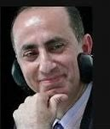  - The Counter Terrorism and Border Security Act of 2019 – This was invoked by Police at St Pancras Railway Station for detaining a Palestinian-British Christian academic and his 8-year-old son on their return from Paris on Good Friday. Professor Makram Khoury-Machool has lived in the UK since 1999 and taught in Cambridge since 2004. He is the founder of the Cambridge Centre for Palestinian Studies, whose board members and patrons include Dr Rowan Williams, Baroness Helena Kennedy, Baroness Sally Morgan, Lord Chris Smith, HE Clare Short, Baroness Warsi and Lord David Steel.  He and his son were held over four hours until after midnight, were given no food while the police took his fingerprints, DNA samples, searched his personal belongings and confiscated his laptop and mobile phone, using the threat of force. He was subjected to an intimate body search, and his son was left traumatised by the experience. This is perhaps the first time a child as young as eight has been detained in the UK under the 2019 Act; his treatment may breach the UN Convention on the Rights of the Child to which the UK is a signatory.  - Economic, Social and Cultural Rights – Amnesty reports that in the UK there is no legislatively defined universal social protection floor such as the one recommended by the UN's International Labour Organisation: this is left to the discretion of the State and is inconsistent across Great Britain and Northern Ireland. The changes proposed by the Pathways to Work Green Paper 2025 will require new legislation allowing the Secretary of State to implement proposed cuts to social security rates for disability and incapacity schemes, and removing some of the legislative protections which are in place to protect against political whims.  If implemented, Amnesty considers the extensive reforms proposed would be a deliberately discriminatory, disproportionate and retrogressive violation of human rights; The UK’s social security system does not legally guarantee essential social security payments that ensure access to basic needs such as healthcare, housing, food and education and that social security freezes, caps, and deductions, removal of the spare room subsidy (bedroom tax) and two-child limit have deepened poverty and disproportionately harmed children, the disabled and low-income families. Despite increased social security spending, poverty rates remain unacceptably high. | LC  AH  FD
6 | Social Media Report  A good level of activity this month. On the website, death penalty matters were of most interest whereas on Facebook, the primary interest was Gaza and our vigils. There is some activity on Bluesky at last with several of our posts being reposted.  Our 50-year anniversary was highlighted in the Amnesty UK magazine for members which is gratifying!  Website  We had 273 views from non-subscribers and 483 from subscribers – 756 all told. We have 39,531 views all time.  Most viewed were:  - The Death Penalty report  - Death Penalty action in Oklahoma  =3 April minutes and the 70th Vigil  Most views were from the US, UK second and Poland third.  The subscriber views on the other hand were somewhat different:  - Amnesty Death Penalty Report  - Vigil number 71  - DP action re: Oklahoma.  Facebook  - The 70th Vigil was most viewed  - The ban on two Labour MPs from visiting Israel (Facebook link)  - The post about members of the Jewish Deputies who wrote to the Financial Times.  There were 349 views altogether.  Bluesky  Signs of life here and we now have 10 followers. Some of our posts have been reposted by the Ealing and Redhill Amnesty groups which is encouraging. | PC
7 | Local Groups & Joint Actions  Follow the link for this month’s Local Groups Update, which contains information on:  - Office Led Campaigns  - Social Security in the UK  - The Niger Delta  - Hong Kong Programme  - End Israeli Apartheid  - Individuals at Risk – with details of exhibition in partnership of Anoosheh Ashoori  - Actions Across Amnesty  - Country Coordinator – South America – with 5 Urgent Actions  - Network Updates – including The Rainbow Network, Pride and Disabled People’s Human Rights  - Amnesty UK Section Board Updates – and update on the implementation of decisions made at the 2024 AGM  - Community Platform Survey  - April Fundraising Update  - Community Organising Team  - Amplify Summit – AGM & National Conference – 5th– 6th July  - Regional Gatherings – East Midlands  - Bank Account for Amnesty Local Groups  - Essential Training Updates – Safeguarding – at least one member of the Group must be trained  - Learning at Amnesty UK  - Prevent – 13th May  - How to Community Fundraise – 27th May  - Human Rights Education in Your Activism – 21st June (initial training)  - Technology & Social Media Guides  - What Groups have been up to  - Individual Groups  - Local Group Spotlight – Salisbury  - Local Group Members Fundraising  - Upcoming dates not listed above  - 8th May – Social Insecurity – Failures in the UK - online  - 21st May Mass Lobby of MPs in Parliament – Disabled People’s HR Network  - 5th June – Immigration Detention in the UK – online.  Follow the link for this month’s Group Urgent Actions, which comprise:  - A call to Parliament in Hungary to allow the June Budapest Pride march can go ahead  - A call for the release from arbitrary detention of British national Ahmed al-Doush in Saudi Arabia  - A request to the Mozambican Authorities to investigate the shooting of opposition politician Venâncio Mondlane in Mozambique  - A call to the Nigerian authorities to overturn the conviction and arrange for the immediate and unconditional release of Yahaya Sheriff-Aminu, sentenced to death for ‘blasphemy’ for circulating a song on social media. | All
8 | Market Stall  This had taken place on 3rd. May. Takings had been disappointing with a profit of £43.39. This appeared to reflect the experiences of other charity stall holders. The question of focusing on a single item – eg books – was discussed but, following discussion, it was agreed the Group would not have a stall in 2026, and would then review the situation. | AH  FD  All
9 | People in the Park – Saturday 17th May – 9.30 – 15.30  The Wheel of Human Rights will be used, together with an action for Indigenous Defenders. PC will produce a handout. FD, AH, VJ and EB will be present from 9.30, PC from mid-morning. Those able to attend not present at the May meeting have been asked to confirm with FD. | AH  All
10 | Evensong – Date still to be confirmed | AH  All
11 | School Visits  The third visit to BWS has been confirmed for the morning of 17th June. As this is the same date as the Eco Stall action for Refugee Week, a rota will need to be produced; | AH  FD
12 | AOB  LC reminded the Group of the 3rd Assemble meeting – the Charter Assembly – on Sunday 1st June from 14.00 – 16.00 at Salisbury Football Club. All welcome – please RSVP welland2@btinternet.com if you wish to attend. | PC  LC
12 | Forthcoming Events  - Cease Fire & Peace Vigils – Saturdays until further notice (photo)  - Evensong at the Cathedral – TBC  - People in the Park – 17th May  - Coffee Morning at St Thomas’s – 5th July  - BWS Visit – 17th July  - Eco Hub Stall – Refugee Petition – 17th July  - Summer Social – 9th August (weather permitting)  - World Day Against the Death Penalty – 10th October  - Write for Rights – 30th November  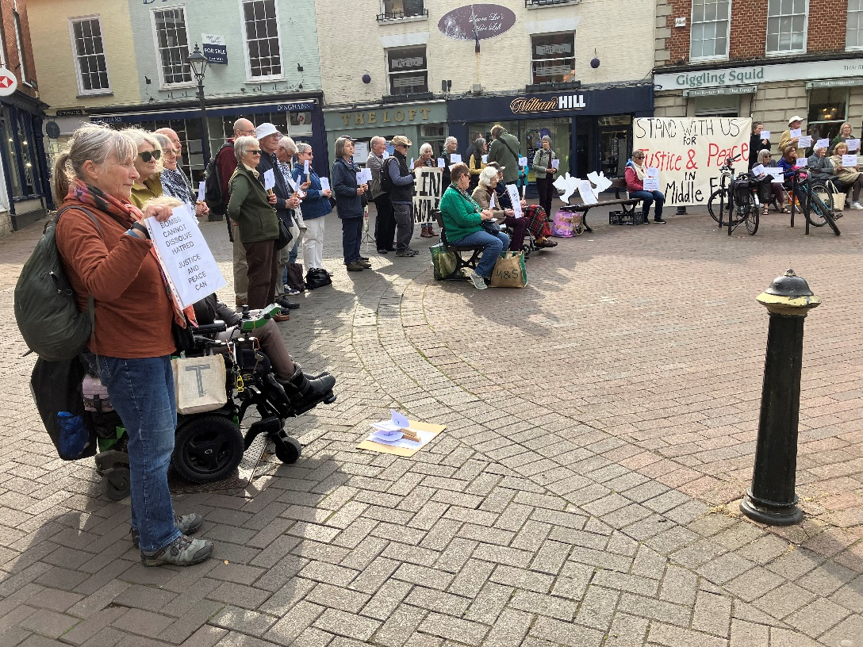
Next Meeting: Thursday 12th June 2025
Time: 2.00 pm
Venue: 4 Victoria Road

www.salisburyai.com Bluesky Facebook

Should you wish no longer to receive Minutes of meetings, or other communications from the Group, please let us know by emailing our Group Secretary at Donovan.fiona@gmail.com

