DEATH PENALTY REPORT: JULY- AUGUST 2025
UK Date format: day/month/year

T
he death penalty is the ultimate cruel, inhuman and degrading punishment. Amnesty opposes the death penalty in all cases without exception - regardless of who is accused, the nature or circumstances of the crime, guilt or innocence or method of execution

International Report (from: 9.7.25 – 5.8.25)

- USA

  - Utah

    - 10.7.25 – A Judge has set a date for execution by firing squad of 5th September of Ralph Leroy Menzies. Mr Menzies, convicted of abduction and first-degree murder in 1988, has dementia. His lawyers argue that his condition is worsening, and he cannot understand his case, which makes him ineligible for execution. Later this month, Judge Matthew Bates will decide whether he should undergo a further evaluation of his cognitive understanding. (Source: ABC News.)

    - 29.7.25 – The Utah Board of Pardons and Parole has granted Ralph Menzies a commutation hearing ahead of his scheduled execution on 5th September. The Board will then decide whether to grant Mr Menzies clemency. If they do so, his death sentence will be commuted to life imprisonment without parole. According to the DPIC, this would be the first time this has happened in the State. No date has as yet been set for the hearing. (Source: Utah News Dispatch.)

  - Oklahoma

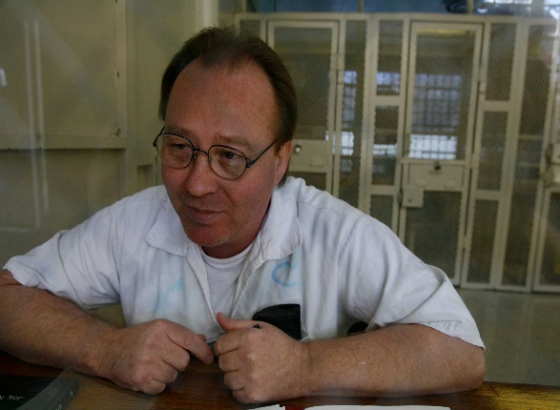
    - 10.7.25 – The State Court of Criminal Appeals unanimously affirmed the death sentence of William Lewis Reece, convicted of rape and murder in a precedential ruling that says sexual propensity evidence may be admitted during some murder trials in Oklahoma. His attorneys had claimed the propositions of error their client had raised during the investigation and trial warranted a new prosecution, but the five Judges said they had found no grounds for reversing the verdict and sentence and denied his application for an evidentiary hearing. (Source: NonDoc.)
    - 16.7.25 – Follow the link for an article from Oklahoma Voice about Richard Glossip, who alleges Attorney General Gentner Drummond entered into a plea deal with him in 2023 which, given the time already served, could set him free immediately. (Source: Oklahoma Voice.)

    - 23.7.25 – District Judge Heather Coyle denied bond for Richard Glossip. This means he will remain in prison while awaiting his re-trial. Ms Coyle stated, ‘The State has sufficiently shown by clear and convincing evidence that the presumption of the defendant’s guilt of a capital offence is great’. Mr Glossip has maintained his innocence throughout the almost 30 years since his conviction. (Source: CNN.)

    - 25.7.25 – Attorney General Gentner Drummond has appointed Ryan Stephenson, the Assistant Executive Coordinator of the District Attorneys Council as a special prosecutor in the Richard Glossip case. (Source: Oklahoma Watch.)

  - Federal Death Penalty – 11.7.25 – A divided Federal Appeals Court has thrown out a plea agreement that would have allowed accused ‘9/11 mastermind’ Khalid Sheikh Mohammed and other defendants to plead guilty in exchange for avoiding the death penalty. (Source BBC News.)

  - Louisiana – 14.7.25 - Follow the link for a post from the DPIC explaining how legislation signed by the Governor in June, and which will come into effect on 1st August, will limit post-conviction appeals and endanger innocent prisoners in an attempt to expedite executions. It will apply to the 55 prisoners currently on death row and almost 5,000 serving life sentences. Prisoners must file complete post-conviction relief applications within 2 years of their direct appeal decision, or forfeit their right ever to do so, even if they later have potentially exonerating DNA evidence. (Source: Death Penalty Information Center.)

  - Florida

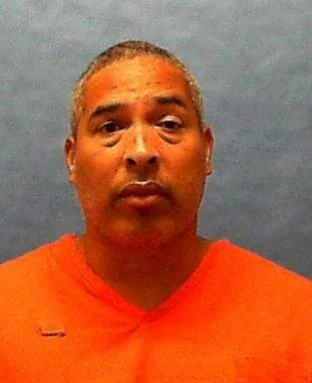
    - 15.7.25 – Michael Bell, convicted of the fatal killing of two people, was executed by lethal injection. He had also been convicted of three further murders. Mr Bell’s lawyers argued the execution should have been halted because of newly discovered witness testimony but this was rejected unanimously by the Justices. The US Supreme Court denied the request for a stay. Note: Florida has carried out 8 executions to date in 2025 – the highest number of any State. (Source: The Guardian.)

    - 28.7.25 – The State’s Attorneys filed documents arguing that the Supreme Court should deny a petition filed by Edward Zakrzewski’s lawyers for a stay of execution. Mr Zakrzewski was convicted and sentenced to death for the murder in 1994 of his wife and two children. His execution is scheduled for 31st July. (Source: WUSF.)

    - 31.7.25 – The execution by lethal injection took place of Edward Zakrzewski. This was the nineth execution in the State this year, setting a new record, with two more scheduled for August. So far this year, it has carried out more executions than any other State, with Texas and South Carolina second, each having executed four. (Source: Sky News/PBS.)

  - Texas

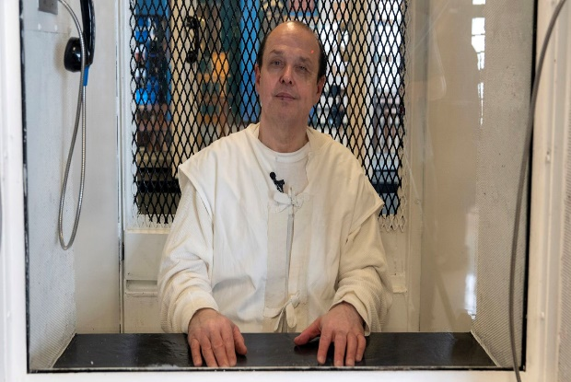
    - 16.7.25 – Following the request of Attorney General for a hearing, a Judge announced that Robert Roberson was set to be executed on 16th October. Mr Roberson was convicted of the murder of his infant daughter on the basis of the discredited theory of Shaken Baby Syndrome. His attorney, who filed his latest appeal in February is to appeal for a stay of execution. (Source: CBS News.)

    - 22.7.25 – Follow the link for a post from the DPIC on a pilot programme, begun in February 2024, which has allowed a select group of prisoners on death row the opportunity to experienced ‘loosened confinement conditions’. They are allowed to mingle in a common room, share meals, and spend time out of their cells without handcuffs or shackles. (Source: Death Penalty information Center.)

    - 25.7.25 – Attorneys for Robert Roberson have filed two motions in the Texas Court of Criminal Appeals asking for his execution date of 16th October be stayed to ensure the Court has sufficient time to complete its review of his pending case. In addition, Mr Roberson has filed a Motion for Oral Argument, which has never been held before the CCA since his innocence was first raised in 2016. (Source: The Innocence Project.)

  - Pennsylvania – 28.7.25 – A group of lawyers defending people facing capital punishment have asked the Pennsylvania Supreme Court to take action to restrict Washington County District Attorney Jason Walsh’s use of the death penalty. According to a petition filed by the Atlantic Center for Capital Representation, Mr Walsh has filed notices of intent to pursue death sentences in 11 out of 18 homicide cases prosecuted by this office since he took office in 2021, and alleges that in 2 pending cases – those of Joran Clarke and Joshua George - he is pursuing the death penalty without evidence to support it. (Source: Pennsylvania Capital-Star/ Death Penalty Information Center.)

  - Tennessee


    - 31.7.25 – The Tennessee Supreme Court has ruled that the execution of Byron Black by lethal injection, scheduled for 5th August, can go ahead without first deactivating his fibrillatory, despite the argument put forward by his defence that it could continuously shock his heart and result in an unnecessarily painful and prolonged death. (Source: Aljazeera.)

    - 5.8.25 – Byron Black was executed by lethal injection. His defibrillator had not been deactivated. (Source: The Guardian.)

  - Alabama - 31.7.25 – State lawmakers are preparing to reintroduce a bill that would make the rape or sodomy of a child a capital offence, punishable by death. In the 2024 legislative session, HB29 would have given adults who committed such offences against a child under six the death penalty or life imprisonment without parole. Amended to extend the punishment to those committing such crimes against a child aged 12 passed the House 86 to 5, but did not make it to the Senate for a vote. (Source: Alabama Reflector.)

  - Links to Research on the Death Penalty in the USA

    - Costs of the US Death Penalty – 9.7.25 – Follow a link to an article from the DPIC demonstrating the death penalty is more expensive than life imprisonment –
      - Capital cases take longer and incur higher costs
      - Incarcerating prisoners sentenced to death requires more resources

These costs fall on tax payers.

    - Mid-Year Review of New Death Sentences – 13.7.25 – Follow the link for a post from the DPIC outlining how new death sentences remain low amidst an increase in executions –

      - The year’s increase in executions reflects the decisions of elected officials in a dew states, not a change in public support;
      - Increased secrecy denies the public critical information about execution decisions;
      - The death penalty remains extremely expensive, but almost all costs are routinely hidden from the public;
      - State legislation to expand the death penalty and adopt new methods is concentrated in 5 States;
      - Executions and new death sentences demonstrate persistent concerns about racial disparities.

    - Facts about the Death Penalty - 21.7.25 – Follow the link for a post from the DPIC challenging assumptions that all victims’ families favour the death penalty, and highlighting that those who do not sometimes experience discrimination within the criminal justice system. (Source: Death Penalty Information Center)

    - Facts about the Death Penalty – 28.7.25 – Follow the link for a post from the DPIC questioning the support of different religions for the death penalty and highlighting the facts:

      - The majority of Judeo-Christian religious organisations oppose the death penalty;
      - Religious beliefs interest with race and ethnicity in shaping death penalty attitudes;
      - Courts vary in their treatment of religious arguments in death penalty trials.

    - The Death Penalty and Elections – 4.8.25 – Follow the link for a post from the DPIC showing that current elections feature viable critical of the use of the death penalty or even non-use. (Source: Death Penalty Information Center.)

- Yemen– 14.7.25 – Nimisha Priya, the Indian nurse sentenced to death in 2020 for the murder of her Yemeni former business partner, and whose execution was scheduled for 15.7.25, was given a last-minute reprieve. Her family have continued to fight for her release, saying she had acted in self-defence. Amnesty and other Human Rights organisations have called on the Houthis not to carry out her execution, with Amnesty calling for her sentence and all those imposed on others to be commuted as the first steps towards a moratorium. (Source: CNN World.)

- Iran

  - 19.7.25 – Two Prisoners – Parviz Sarlak and Mohammad Ahmadkhani, arrested and sentenced to death following their arrests for murder, were executed. (Source: Iran Wire/Human Rights Activists News Agency.)

  - 20.7.25 – Six Baluch prisoners, arrested in 2021 in separate drugs-related charges and sentenced to death, were executed at Zahedan Central Prison. Three were named as Abdoljalil Darkzehi, Nematollah Shahnavazi and Dariush Shahbakhsh. (Source: Iran Wire.)

  - 28.7.25 – Follow the link for a press release from the OHCHR: Office of the High Commission – United Nations Human Rights.) with a message from the UN Human Rights Chief, Volker Türk, referring to the deeply disturbing situation regarding executions and the urgent need for a moratorium on the use of the death penalty. (Source: OHCHR.)


  - 28.7.25 – Follow the link for a press release from Amnesty responding to the arbitrary executions of tortured political dissidents Behrouz Ehsani and Mehdi Hassani, and raising concerns about the possible imminent executions of others. These fears have emerged since the ’12-day war’ with Israel, with mass arrests, orders to expedite trials and executions and an emergency bill that would expand the scope of the death penalty. (Source: Amnesty International.)

- Pakistan - 21.7.25 – A bill has been passed by the Senate abolishing the death penalty for two specific offences – harbouring hijackers and stripping a woman of her clothes in public. This is in order to bring the country’s laws in alignment with its obligations under the EU GSP-Plus trade agreement, which requires Pakistan to ensure the death penalty is reserved only for the most serious crimes. Both the aforementioned offences will now result in life imprisonment. (Source: dawn.com.)

- Saudi Arabia

  - 22.7.25 – Stephen Abdukareem Munyakho, a Kenyan man who has been on death row in Saudi Arabia for more than a decade, has been released following a lengthy campaign to save him from execution. Mr Munyakho had been convicted of the murder of a Yemeni colleague in 2011, a crime carrying the death penalty. He has been released following protracted negotiations with the victim’s family, resulting in the payment of ‘dihya’, blood money. (Source: The BBC.)

  - 2.8.25 – The official Saudi Press Agency (SPA) reported that four Somalis and three Ethiopians were executed in the southern region of Najiran for ‘smuggling hashish into the Kingdom, and one for the murder of his mother. An AFP tally of official reports indicates that, since the beginning of 2025, Saudi Arabia has carried out 230 executions, 154 of which were on drug-related charges. (Source: NDTV.)

  - 4.8.25 – Two executions of Saudi nationals, who had been convicted of terrorist offences, took place. Together with a further 15 executions of foreign nationals – mainly for drug offences – this brings the total to 17 over 17 days. (Source: CBS News.)

- Indonesia – 24.7.25 – Three British nationals – Lisa Stocker, Jon Collyer and Phineas Float (pictured below) – arrested in February at Bali airport, and caught with cocaine disguised as packets of Angels Delight, have avoided the death penalty and been told by a Judge they will serve 12 months in prison. (Source: BBC News.)

- The Death Penalty Project – 25.7.27 – Follow the link for the Summer Newsletter from The Death Penalty Project. This contains information on:

  - Africa’s growing abolitionist movement and work remaining to be done in Ghana and Zimbabwe;
  - Two major legal victories in the Caribbean
  - Deeply troubling executions in Taiwan and Japan
  - The Project’s continuing successful collaborative work.



