DEATH PENALTY REPORT: AUGUST - SEPTEMBER 2025
UK Date format: day/month/year

T
he death penalty is the ultimate cruel, inhuman and degrading punishment. Amnesty opposes the death penalty in all cases without exception - regardless of who is accused, the nature or circumstances of the crime, guilt or innocence or method of execution

International Report (from: 6.8.25 – 8.9.25.)

- The USA

  - Florida

    - Note: See under Links to Research below a post from the DPIC on Troubling patterns of Secrecy and Inadequate Legal Representation with reference to executions in Florida. See also analysis of number of execution warrants issued to date this year, with reference to more than a third having been issued by Governor De Santis.

    - 8.8.25 – Following the nineth execution this year in the State – that of Edward Zakrzewski on 31st July, Bishops at the Florida Conference of Catholic Bishops have called for a ‘Novena’, asking the faithful to pray for an end to Florida’s death penalty. (Source: The Catholic World Report.)

    - 11.8.25 – More than 130 US veterans have called on Governor DeSantis to end executions of convicted American military vets.. This was in advance of the execution scheduled for 19th August of Kayle Barrington Bates. Mr Bates, convicted of murder, would be the fourth veteran and tenth individual to have been executed in Florida. (Source: UPI.)

    - 11.8.25 – Attorneys for Curtis Windom, convicted of the killing of three people and whose execution was scheduled for 28th August, argued that he should not be executed because of incompetent legal representation during his trial in 1991. (Source: WUSF.)

    - 13.8.25 – Follow the link for a post from the DPIC regarding the filing of fresh charges by two prisoners on death row, Curtis Windom and Kayle Barrington Bates (aka Maud dib al Sharif), alleging the signing of governor DeSantis’s tenth and eleventh warrants for their executions was part of a process ‘infected with racial discrimination and unconstitutional arbitrariness’. (Source: Death Penalty Information Center.)

    - 14.8.25 – Former Alabama Governor Don Siegel revealed he had ‘lived to regret’ not commuting death sentences while in office, and criticised Florida’s selection process, citing serious concerns with secrecy and racial bias. Follow the link for a post (20.8.25) from the DPIC highlighting the cases of Kayle Bates and Curtis Windom. (Source: Death Penalty Information Center.)


    - 15.8.25 – Governor DeSantis signed the execution warrant for David Pittman, which is now scheduled for 17th September. Mr Pittman was convicted of the murder of his estranged wife’s sister and parents. His would be the 12th execution to take place in the State this year – a record high (Source: CNN.)

    - 19.8.25 – The execution by lethal injection of Kayle Barrington Bates took place on the evening of 19th August. (Source: CBS News.)

    - 28.8.25 – The execution of Curtis Windom was carried out by lethal injection, the 11th execution to take place in Florida this year. His daughter, Curtisia Windom, said, if she and the family could forgive him, she felt those who had not experienced their pain should not have a right to say he should die. (Source: The Guardian.)

    - 30.8.25 – Governor De Santis signed the death warrant for the execution on 30th September of Victor Tony Jones. Mr Jones was convicted and sentenced to death in 1993 on two counts of first-degree murder. He had also been found guilty of armed robbery. The Florida Supreme Court is scheduled to hear an appeal, and an appeal is also likely to be filed with the US Supreme Court. (Source: Tampa Bay Times.)

  - Tennessee – 9.8.25 – The Defense Attorney of Byron Black – who was executed on 5th August – reported how his execution was ‘botched’, causing him immense suffering. Follow the link for further information. (Note: this contains distressing details.) (Source: The Guardian)

  - California – 11.8.25 – Matthew Stepka, a prominent business executive and member of the 500-strong Coalition Business Leaders Against the Death Penalty, has called on Governor Gavin Newson to commute all death sentences to life without parole, saying the State’s death penalty system is a failure of both justice and fiscal responsibility. He said, ‘If any company or product I had evaluated had an error rate comparable to the death penalty – where for every eight people executed one person has been exonerated – I would never invest.’ (Source: Death Penalty Information Center.)

  - Arkansas

    - 12.8.25 – Follow the link for a post from the DPIC on the lawsuit filed on 5th August by a group of prisoners on Arkansas’s death row challenging as unconstitutional a new law authorising their executions with the use of nitrogen gas. They argue the new law gives state officials ‘unfettered discretion’ to choose a method of execution different from lethal injection, to which they were sentenced, with no guidance or protocol about the use of nitrogen gas in place. (Source: Death Penalty Information Center.)

    - 18.8.25 – Scotty Gardner, who has been on death row for murder since 2071, unlike the prisoners noted above, has continued to call for his execution to take place by any means available and sent an email to USA Today citing the conditions of his cell with mould, bugs and poor plumbing. (Source: New York Post.)

    - 21.8.25 – Faith Leaders petitioned Governor Sarah Huckabee Sanders not to re-start executions in the light of a new law allowing the use of nitrogen gas in carrying out the death penalty. The letter was signed by 43 faith leaders – Christian, Jewish and Buddhist. (Source: Arkansas Advocate.)

  - Alabama

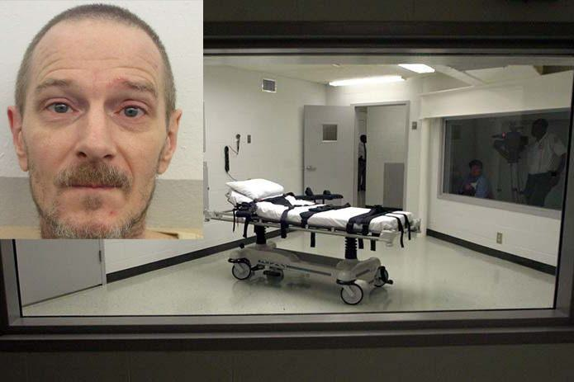
    - 15.8.25 - The execution of David Lee Roberts, previously scheduled for 21st August but stayed last month, remains on hold for a psychiatric evaluation of his competency to be executed is carried out. Convicted of a killing in 1992, the execution would have taken place by nitrogen gas. (Source: New York Post.)

    - 20.8.25 – Governor Ivey set an execution date of 23rd or 24th October for Anthony Boyd despite his lawsuit challenging the State’s use of nitrogen gas as unconstitionally ‘cruel and unusual’. A hearing was scheduled for 4th September – no further information. (Source: The Washington Post.)

  - Illinois – 19.8.25 – Follow the link for a post from the DPIC about the dismissal of charges and the issuing of a Certificate of Innocence for Robert Melock, who had spent 34 years on death row following his wrongful conviction and death sentence for sexual assault and murder. Mr Melock was the 201st person to be added to the DPIC’s Innocence Data Base. (Source Death Penalty Information Center.)

  - Utah

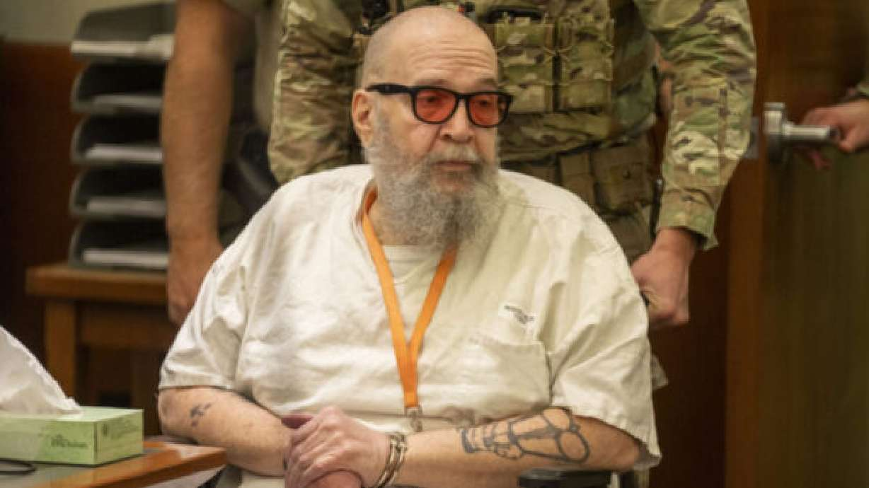
    - 19.8.25 – The Utah Pardons Board denied Ralph Menzies’s petition for commutation despite his worsening dementia, failing health and evidence that his 1988 death sentence ‘was imposed in error’ and ‘obtained using perjured testimony’. Mr Menzies, convicted of murder, is scheduled to be executed by firing squad on 5th September. His attorneys argue that he is incompetent to be executed, and that his execution is, therefore, unconstitutional. (Source: Death Penalty Information Center.)

    - 30.8.25 – The Utah Supreme Court blocked the execution of Mr Menzies by firing squad on 5th September, saying that he had adequately alleged a substantial change of circumstances and raised a significant question on his fitness to be executed. They concluded a lower court must re-evaluate his competency. Source: CNN.)

  - Federal Death Penalty – 22.8.25 – The Justice Department is facing difficulties in following through on the Trump campaign promise to resume federal executions as it revisits cases in which predecessors explicitly decided against seeking capital punishment. Since February, the Attorney General has authorised prosecutors to seek the death penalty against 19 people, including 9 in cases in which President Biden’s administration had sought lesser sentences; however, Judges have blocked those reversal attempts in all but 2, arguing that they do not take account of important constitutional and statutory rights. (Source: PBS.)

  - Idaho

    - 23.8.25 – Attorneys for Thomas Creech, Idaho’s longest-serving prison on death row are renewing their efforts to spare him form execution by lethal injection. (An attempt to execute Mr Creech in February 2024 failed when those involved were unable to find a suitable vein). Left with post-traumatic stress disorder and ‘profound psychological damage’, his lawyers say a further attempt would violate the US Constitution’s Eighth Amendment. Note: Idaho has not carried out an execution for over 13 years. Currently transitioning from lethal injection to a firing squad, the State is being sued by 3 news outlets for improved access to the concealed room where the injection drugs are prepared and administered; a federal injunction barring executions has been in place since April. (Source: East Idaho News.)

    - 2.9.25 – It has been reported that the corrections system is developing a remote firing squad for executions with the aim of minimising the involvement of correctional staff. (Source: Corrections 1.)

    - 5.9.25 – The Idaho State Supreme Court denied the appeal of the only woman – Robin Row – on death row, convicted of three murders over 30 years ago. Ms Row’s lawyers argue she received inadequate legal representation at her original trial when evidence of her brain damage was not presented to the Court. (Source: Idaho Statesman.)

  - Washington DC

    - 26.8.25 – President Trump has said he plans to seek the death penalty for suspected murderers in Washington DC, claiming it would be a ‘preventative’ measure. Most murders in the city are prosecuted under local law, although prosecutors can – in theory – seek the death penalty for crimes that come within federal law. It can, however, be used only if the jury agrees; most residents are opposed to capital punishment. (Source: The BBC.)

    - 28.8.25 – Follow the link for an article from the Los Angeles Times, raising concerns at President Trump’s pronouncement as ‘the rhetoric of making a better society – often by purging perceived threats to order – even if that requires force, or the loss of rights’, and linking it to authoritarianism in other repressive regimes. (Source: Los Angeles Times.)

    - 29.8.25 – Follow the link for an article from The Guardian describing how the President’s death penalty pledge for Washington DC is ugly racial politics. (Source: The Guardian.)

    - 2.9.25 – Follow the link for a post from the DPIC on whether President Trump can impose mandatory death sentences for all murders in DC which highlights how the proposal, if imposed, would violate almost 50 years of legal precedent and overwhelm Washington DC’s legal system, citing the expense, additional mandated rules and restrictions, the jamming of the system and the finding by Supreme Court of previous possible proposals as unconstitutional. (Source: Death Penalty Information Centre.)

  - Texas – 1.9.25 - A status case for David Leonard Wood, convicted of six killings, is to take place on 15th September. This will focus on the next steps following the order of the Texas Court of Appeals that his case should be re-examined by a trial court over allegations that his constitutional rights were violated during his 1992 trial. Mr Wood has been granted two stays of execution. (Source: El Paso Times.)

  - Indiana – 3.9.25 – Debates continue around the State’s supply of pentobarbital and whether it can be used safely in the execution of Ray Lee Ward scheduled for execution on 10th October. (Source: 14 News.)

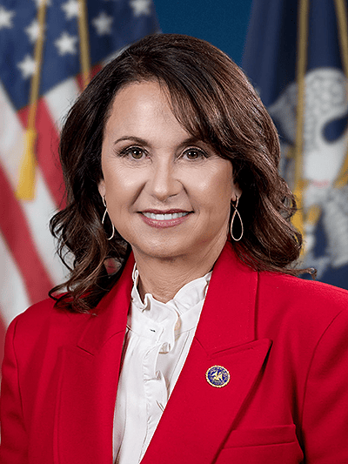
  - Louisiana – 3.9.25 – Attorney General Liz Murrill (pictured) is moving to reinstate the death penalty for Dale Dwayne Craig convicted of a murder committed 8 days before his 18th birthday and initially sentenced to death. Note: The US Supreme Court has banned the execution of offenders under 18 at the time of the crime.) (Source: Pelican Post News.)

- Links to Research on the Death Penalty in the USA

  - Facts About The Death Penalty – 6.8.25 – Follow the link for a post from the DPIC demonstrating the inherent risk of executing innocent individuals (Source: Death Penalty Information Center.)

  - Troubling Patterns of Secrecy and In adequate Legal Representation – 7.8.25 – Follow the link for a post from the DPIC highlighting this issue with particular reference to Florida, but highlighting also that at least 57 prisoners nationwide lost their chance for a federal review because their attorneys did not fail their claims in time. (Source: Death Penalty Information Center.)

  - Americans’ Views on the Death Penalty – 29.8.25 – Follow the link for an analysis State-by-State of current views on the legality of the death penalty, together with additional key demographics of party, religion and race. (Source: Public Religion Research Institute.)

  - Active Death Warrants – 8.9.25 – Follow the link for an analysis carried out by the DPIC of the 40 active death warrants issued to date in 2025. More than a third have been issued by Governor De Santis in Florid, one of only two States where the authority to issue warrants is solely in the hands of the Governor. (The second State, Pennsylvania, where there is currently a moratorium, have carried out no executions for over 25 years.) (Source: Death Penalty Information Center.)

- Iran
  - 9.8.25 – According to information obtained by Iran Human Rights, two co-defendants on death row for drug-related offences – Hashem Sorkhi and Rahman Jahangiri – were hanged in Yazd Central Prison. (Source: IHRNGO.)


16.8.25 – The Supreme Court upheld the death sentence imposed on political prisoner Sharifeh Mohammadi, (picture: Amnesty Austria) despite having left unaddressed the flaws that had previously led to the ruling being overturned. Iran Human Rights has once again warned of the imminent danger of execution for all political prisoners and those accused of espionage following the 12-day Israel-Iran War. (Source: IHRNGO.)

  - 19.8.25 -According to HRANA News Agency, Saeed Joghatay was executed by hanging at Sabzevar Prison. He had been sentenced to death on drug-related charges by the Revolutionary Court. According to IHRNGO’s 2004 Annual Report on the Death Penalty, at least 503 people were executed for drug-related charges, with under 3% announced by official sources. 17% of all drug-related executions in 2024 were Baluch minorities (2.6% of the population.) At least 347 people have been executed for drug-related offences in the first 7 months of 2025. (Source: Iran Human Rights.)

  - 7.9.25 – Azard Moradi, a Kurdish man, was hanged in Sanandaj Central Prison. He had been convicted of murder. (Source: Iran Human Rights.)

- Saudi Arabia

  - 11.8.25 – Human Rights Watch and The Middle East Democracy Center have expressed concern at the unprecedented surge in executions in the Kingdom in 2025 without apparent due process, and cited the 14th June execution of Turki al-Jasser, a journalist known for exposing corruption within the royal family as an indication that the Government is using the death penalty to crush peaceful dissent. Reprieve report that Saudi authorities had executed at least 241 people in 2025 as of 5th August , which would exceed all prior records should executions continue at the same rate. (Source: Human Rights Watch.)

  - 5.9.25 – UN experts have expressed dismay at the ongoing and planned executions of persons under 18 at the time of the offence, with particular reference to Jalal al-Labbal on 29th August. The family were not informed and learned of his execution through social media. (Source: OHCR.)
- The Maldives - 13.8.25 – Follow the link for details of a Joint Public Statement from Amnesty International and 8 other organisations expressing alarm at the statement by Dr Mohamed Muizzu, President of the Republic of the Maldives, made on 30th July 2025, seeking legislative amendments to introduce the death penalty for drug trafficking. (Source: Amnesty International.)

- Israel/US – 20.8.25 – The US Reform movement’s Religious Action Center (RAC) has sent a letter to US Attorney General Pam Bondi stating the group’s opposition to the death penalty for Elias Rodriguez, accused of killing two staff members of the Israeli embassy in Washington DC earlier this year. (Source: The Times of Israel.)

- Tanzania – 21.8.25 – The Tanzanian Government is facing increase pressure from campaigners to release Lemi Limbu, who has been in death row for 13 years. Ms Limbu was convicted of the murder of her daughter. A survivor and brutal and repeated sexual and domestic violence, she has the developmental age of a child, and her legal team are worried about her deteriorating health. (Source: The Guardian.)

- India

  - 21.8.25 – The Calcutta High Court upheld the conviction of Hasina Sultana and Sk Vannur Shah for the murder of the former’s 19-month-old child, but commuted their death sentences to life imprisonment without remission for 40 years. (Source: Times of India.)

  - 25.8.25 – The Supreme Court allowed the reconsideration of the death penalty on Vasanta Sampta Dupare, convicted of the rape and murder of a child. The 2017 verdict, which had upheld Mr Dupare’s death sentence, was set aside with a ruling that capital cases can be reopened under Article 32 of the Constitution if mandatory guidelines for sentencing are not followed. In this case there had been a breach of procedural safeguards. A fresh hearing is to be carried out, together with the collection of Mr Dupare’s psychiatric and psychological evaluation report. (Source: The New Indian Express.)

  - 3.9.25 – The death penalty has been imposed on a Mr Kishandas, convicted of burning alive his wife over the colour of her skin. Mr Kishandas’s lawyer says he is innocent and will appeal against the order. (Source: The BBC.)

- Congo – 22.8.25 – Congo’s Public Prosecutor has asked for the death penalty for President Joseph Kabila, who is on trial in absentia in a treason case that includes war crimes changes related to his ties to the M23 rebel group. (Source: News Tribune.)

- Singapore – 26.8.25 – A survey by MHA of 12,000 residents in six major regional cities found that 84% of residents believe Singapore’s death penalty to be a deterrent for drug trafficking, according to Mr K Shanmugam, the Coordinating Minister for National Security and Minister for Home Affairs. (Source: Yahoo News.)

- Syria – 2.9.25 – An investigation by Amnesty International has revealed that extrajudicial executions have been carried out by government and affiliated forces in military uniforms, some bearing official insignia, with 46 Druze men and 2 women deliberately and unlawfully killed. These executions took place on 15th/16th July in a public square, residential homes, a school, a hospital and a ceremonial hall in the city of Suwayda. Amnesty have called for the Syrian Government to hold those involved accountable. (Source: Amnesty International.)

- Israel – 8.9.25 – Following the shooting attack in Jerusalem, Mr Ben Gvir’s far right Otzma Yehudit party announced it would raise the issue of implementing the death penalty for terrorists in next week’s Knesset National Security Committee. (Source: Times of Israel.)

Urgent Actions – None were received.

Campaigning

- Oklahoma Campaign

  - For the month of July, the Group were asked to send greetings card to Richard Glossip expressing pleasure that a new trial had been agreed and without recourse to the death penalty. They were invited to mention the hope that his application for a bond (bail) would be agreed. This was, however, rejected and Mr Glossip has remained in prison.

No action was planned for August (with no meeting to agree this) but – as a number of Mr Glossip’s cards were returned with details of a new address - it was suggested that, should they wish, members of the Group might like to re-send them to the corrected address.

  - Proposals for the September action will be discussed at the meeting on 11th September.

- World Day Against the Death Penalty 2025 – 10th October – Paul Bridges has responded to LC’s request for information on this year’s national action by Amnesty. As for this last year, there will be a theme for the year, with monthly actions, this time provided by Amnesty. The theme will be the death penalty when used for crimes other than intentional killing (ie in contravention of international law.) The actions will highlight examples and countries operating in this way with requests to write to those countries or their embassies.

An online workshop will be held on 11th October (the day after World Day….) which LC will attend. (Others welcome.)

Options for an action for the day itself will be discussed at the September meeting. One suggestion would be a final letter to Governor Stitt referencing the year’s campaigning, highlighting our overall opposition to the death penalty and/or any particular issues with its practice in Oklahoma.

Note: No Newsletter was received for August-September from the Amnesty Anti-Death Penalty Campaign. It is expected that one will be sent shortly with details of the upcoming campaign.

