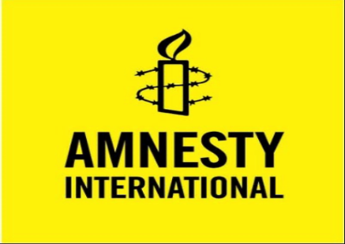 | Something you can do …

I
n December 2024, Israeli forces raided Kamal Adwan hospital in North Gaza and arrested Dr Hussan Abu Safiya along with other medical staff. Fourteen months later he is still a prisoner in an unknown location somewhere in Israel.
He has not been charged or brought before a court. It is likely that he has been subjected to brutal treatment which may include the use of electricity and beatings. He has been denied medical care and access to a lawyer.
The hospital where he worked was destroyed and the IDF claimed it was used by Hamas as a command centre. Dr Safiya has written critical pieces about the IDF in the New York Times.
What you can do:
Write to the Military Advocate General Maj. Gen. Itai Ofir in Israel by email: Pazar@idf.il and ask:
- To disclose the whereabouts of Dr Safiya
- Ask that he be protected from all forms of torture and ill-treatment including coercion
- That he has access to legal counsel
- And that he has access to medical treatment.

Find out more
If you want to find out more about this case and others like it where hostages have been taken and held incommunicado in Israel, you can find information on various sites.
This specific case: https://www.amnesty.org.uk/en/petition/release-dr-hussan-abu-safiya
Other sites: British Medical Journal; Al Jazeera; BBC; CBC (Canada); Middle East Eye; The Independent; Human Rights Watch; CNN, Sky News; Le Monde and others.
Israel’s response
Israel is now claiming, 14 months after his arrest, that Dr Safiya is a member of Hamas. Source: Times of Israel; Jerusalem Post where a photo is posted [accessed 26 February].

